**PROJECT DOCUMENTATION ON**

**ORPHANAGE MANAGEMENT SYSTEM**



**GROUP - 31**

***BACHELOR OF TECHNOLOGY B. TECH***

**(COMPUTER SCIENCE & ENGINEERING)**



**INDIAN INSTITUTE OF INFORMATION TECHNOLOGY**

**SRICITY.**

**TEAM MEMBERS OF WAD GROUP – 31**

**• BHARATH KAMASANI – S20190010080(LEADER)**

**• ROKESH REDDY KONGAMUDI – S20190010098**

**• HARSSHATH MATCHA – S20190010116**

**• PRABHU TEJA SABHAVAT – S20190010155**

**• GOVARDHAN NAIK PATHLAVATH – S20190010135**

**ACKNOWLEDGEMENTS**

My sincerest thanks to the WAD FACULTY whose Grace and wisdom has been sufficient for us without him I couldn’t have gotten this far. I also own special debts in many ways to those who helped in diverse ways in making this project work a reality.

My profound gratitude also goes to WAD FACULTY (DR. BALAJI RAMAN, DR.GIRISH.GN, DR. HIMANGSHU SARMA, DR. BHEEMAPPA HALAVAR, DR. RAKESH KUMAR SANODIYA), who were objective but quite supportive and offered valuable suggestions, guidance and moral support.

Also to my Honorable Director Prof. GANESAN KANNABIRAN for the moral support, mentorship and efforts.

May God bless you all.

**DOCUMENTATION**

**PROBLEM STATEMENT:**

Orphans are the children who lost their parents or abounded from the family. The orphans face very challenging conditions in the society. orphanage provides very good environment to the orphans by providing good quality education and decent food. But all orphanages can’t afford everything to orphans. Food can't be served to all children in the orphanage or small amount of food is distributed. due to this, children are not getting sufficient healthy food. this will definitely affect their physical and mental growth. Children should spend their childhood happily and healthily. this reflects their behavior and character of future. all the time orphanage people can’t provide the clothes and toys to all children. In everyone's life birthday is a special day for children its a very big thing. But in orphanage food and education combinedly is a big problem to orphanage people. So they can't afford for this celebrations. Orphanage people can't monitor and review each individually child in the orphanage. So many people outside in the world are willing to donate and help orphan children. But they don't know the way to donate amount, sponsor a child and how to share their old clothes and toys. And there are some people how are willing to do volunteer works in orphanages. But due to lack of guidelines they are also not volunteering.

**PROBLEM SOLUTION:**

So to overcome the Above discussed problems our team decided to build a web application which can help the orphanages and support the children and guides the donors. And also instruct the process of adoption to adopters. This Orphan Home Management System will help to improve the performance of current situation and overcome the problems that arise nowadays. We collaborate with a set of orphanage homes in a specific city and we will work for them.

How to run:

First you need to download and install Django :

Steps for installing is:

1.open terminal and install pip

2.now create a folder Django .in which we will create an environment for Django to work

3.In terminal go to that folder and run this command “python -m pip install Django”.

4.Now ,your django environment is created. You will be given a file [myproject.zip] file .Download it and extract it. And keep it in this django folder.

5.Now open Vscode and open this myproject folder in that .

6.open the terminal in vscode and run these commands:

“Python manage.py makemigrations”

“Python manage.py sqlmigrate <Name of the App> 0001”

“Python manage.py migrate”

“Python mange.py runserver”

7.now the server has began and it’s time to get into website.

Open browser and type “http://127.0.0.1:8000” in the search bar. From that point you are on our website.

**SYSTEM SPECIFICATION:**

SOFWARE REQUIREMENT SPECIFICATION:

OPERATING SYSTEM: WINDOWS

FRONT END: HTML, CSS, Java Script

BACK END: MY SQL(PostgreSQL), PYTHON ,DJANGO.

**HARDWARE SPECIFICATION:**

**The following are the hardware devices that will be needed for the system**

**➢ A personal computer (Core i3, 1.70GHz or higher recommendation)**

**➢ Minimum RAM of 2GB**

**➢ Uninterrupted Power Supply (UPS)**

**➢ Printer.**

**SOFTWARE DESCRIPTION:**

➢ Operating System: Windows Xp, Windows 7, 8, 10

➢ Browser: Mozilla Firefox, Internet explorer, Chrome.

➢ Macromedia products: Dreamweaver Photoshop flash

➢ Database tool: PostgreSQL (PgAdmin 4)

**PostgreSQL:**

➢ PostgreSQL is a database server.

➢ PostgreSQL is a multi-threaded, multi-user server.

➢ PostgreSQL supports standard SQL.

➢ PostgreSQL compiles on a number of platforms.

➢ PostgreSQL is free to download and use.

SETTING MANAGEMENT IN DJANGO :

Defining the App applications in the INSTALLED_APPS of settings.py file.

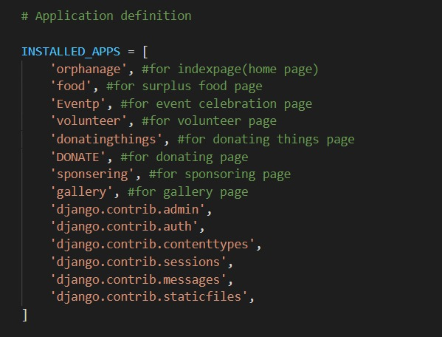

STATIC FILES AND MEDIA FILES :

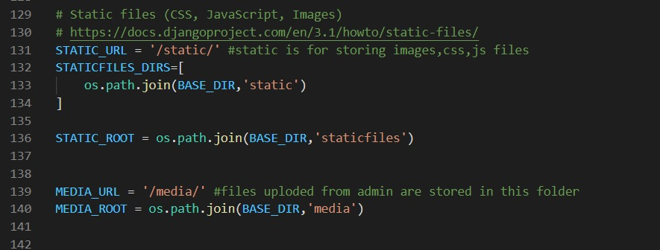

DATABASES :

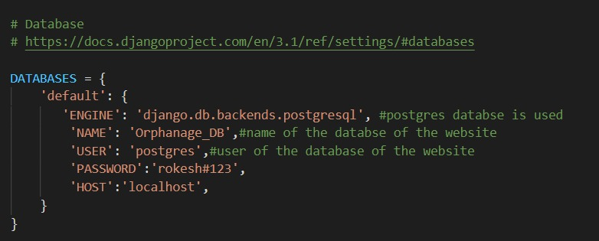

TEMPLATE FOLDER : HOLDING HTML FILES.

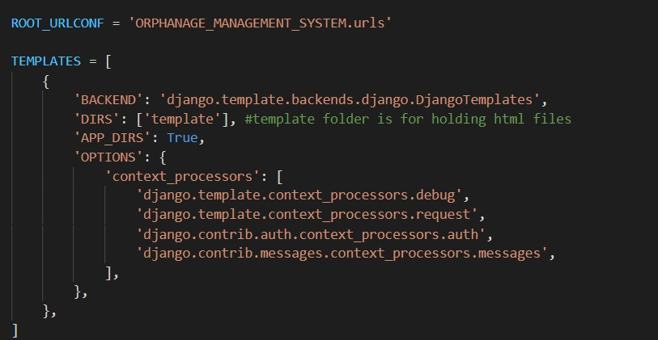

URLS.PY FILE.

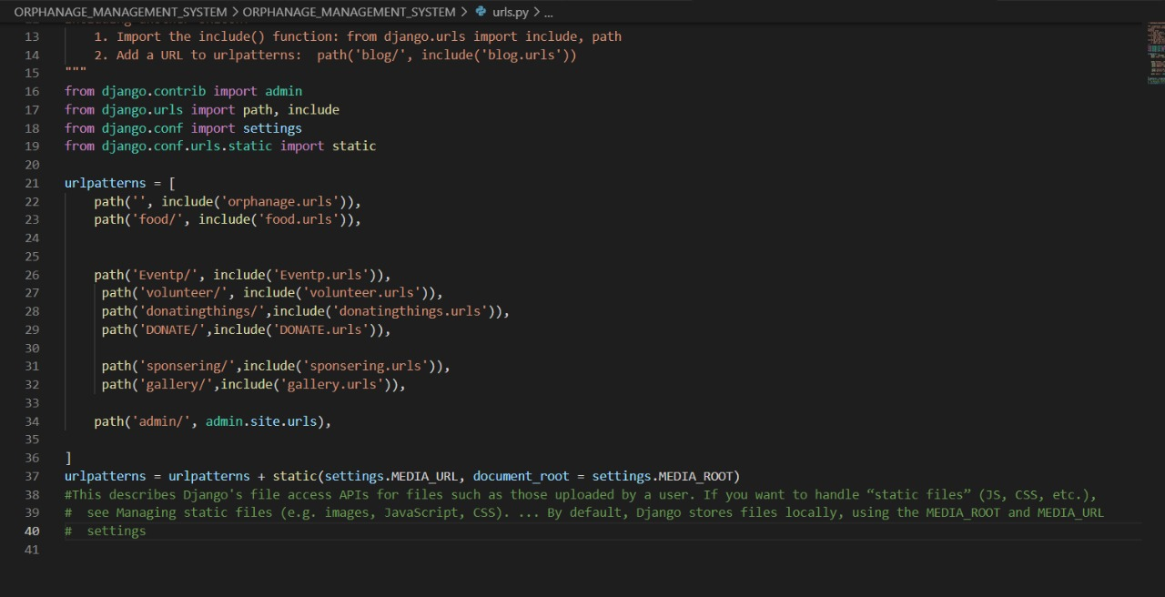

USE CASE DIAGRAM:

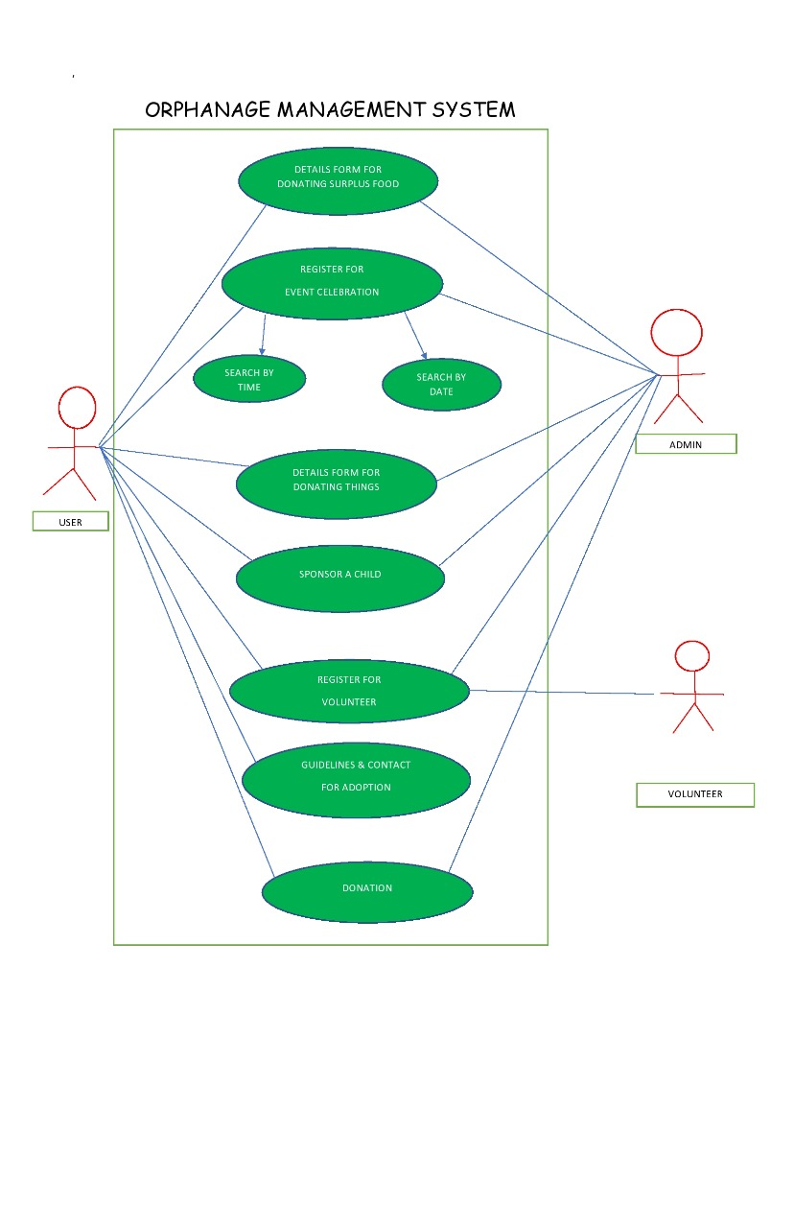

SEQUENCE CASE DIAGRAMS:

SURPLUS FOOD:

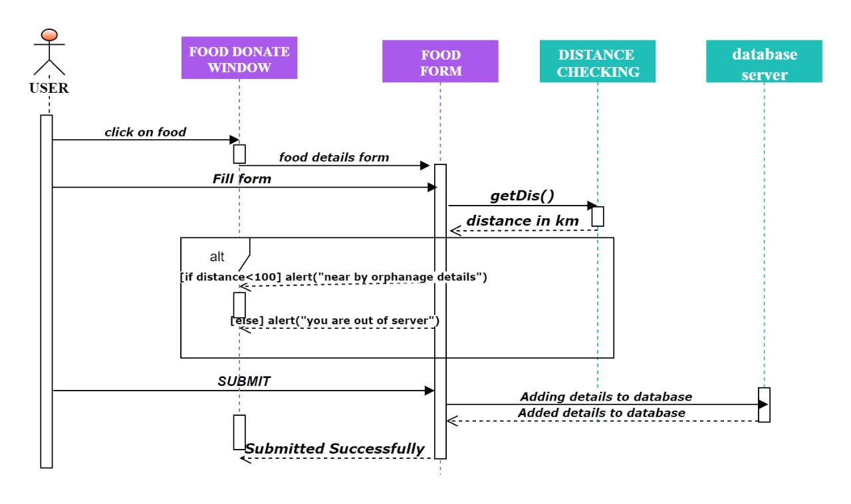

SPONSOR A CHILD:

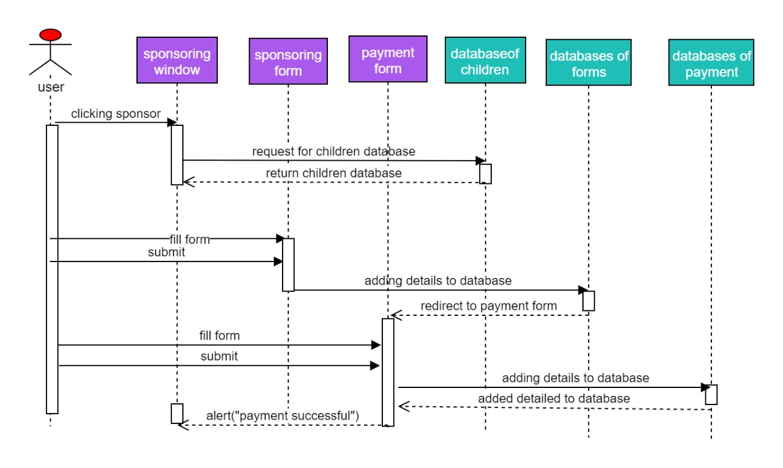

VOLUNTEER:

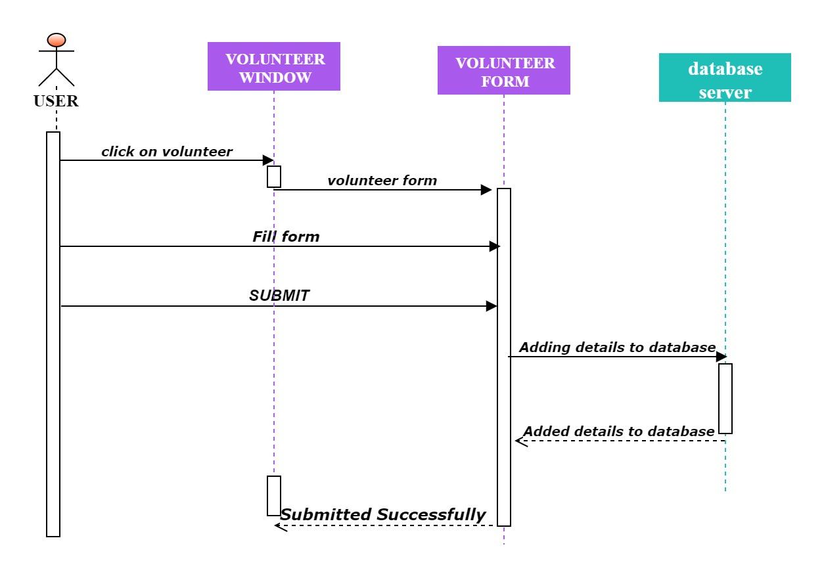

DONATING THINGS:

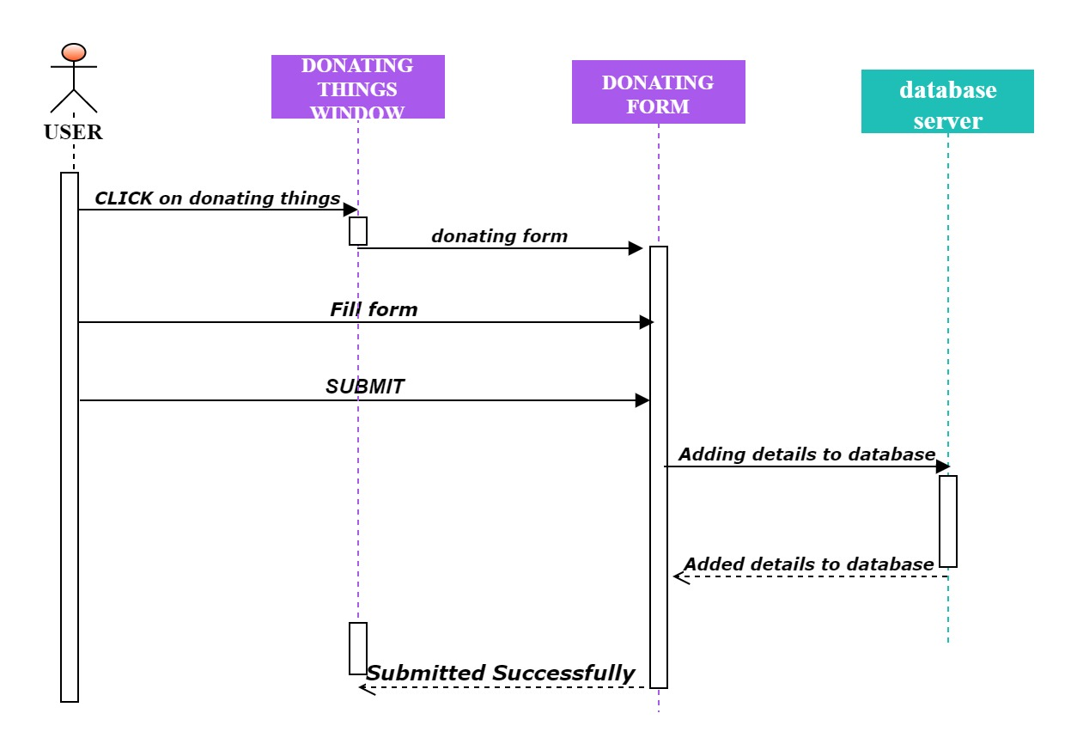

EVENTS:

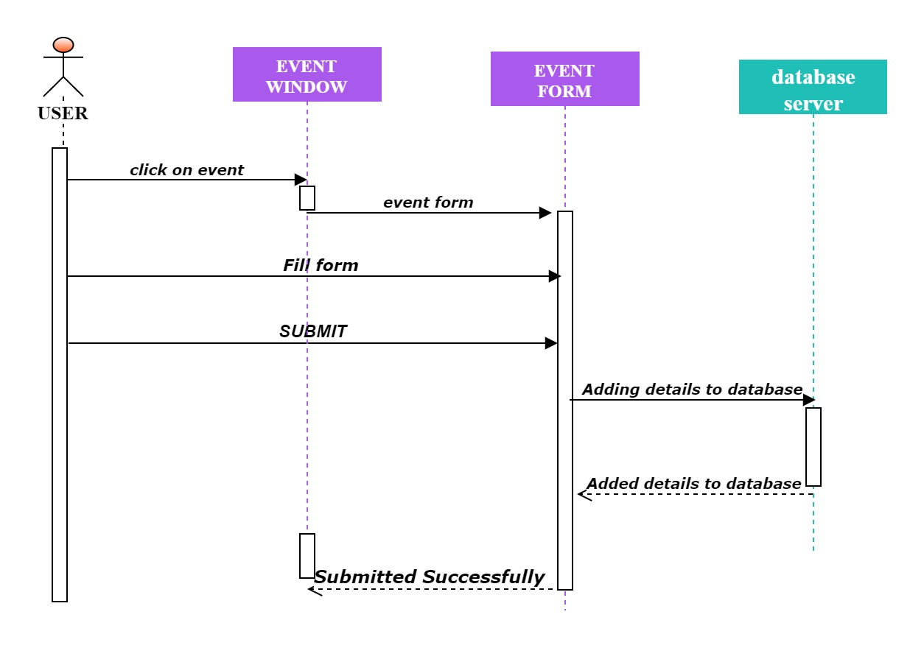

OVERVIEW OF PAGES:

HOME PAGE OF OUR WEBSITE:

The Home Page of the website. The Navigation bar in the Home page navigates the user to find the respective features. All features are mentioned in the navigation bar. The user can easily

select the features they want.

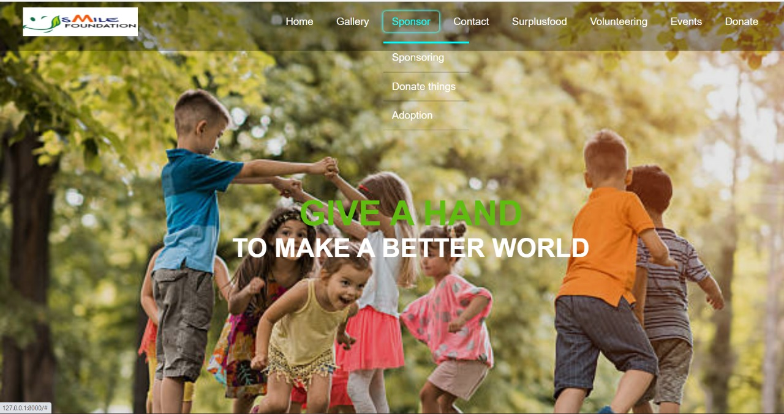

THIS INDEX FUNCTION IS TO RECEIVE WEB REQUEST AND OPENS HOME PAGE OF THE WEBSITE.

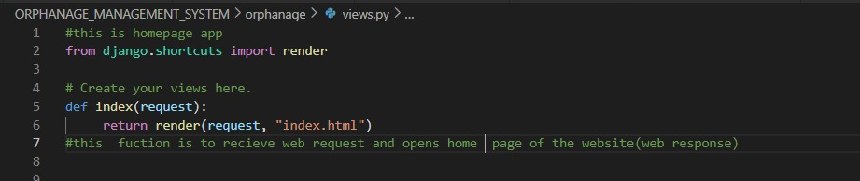

GALLERY OF THE WEBSITE:

On clicking the GALLERY button in the navigation bar , it takes the user to the gallery page. In the gallery the user can find the orphanage home related images.

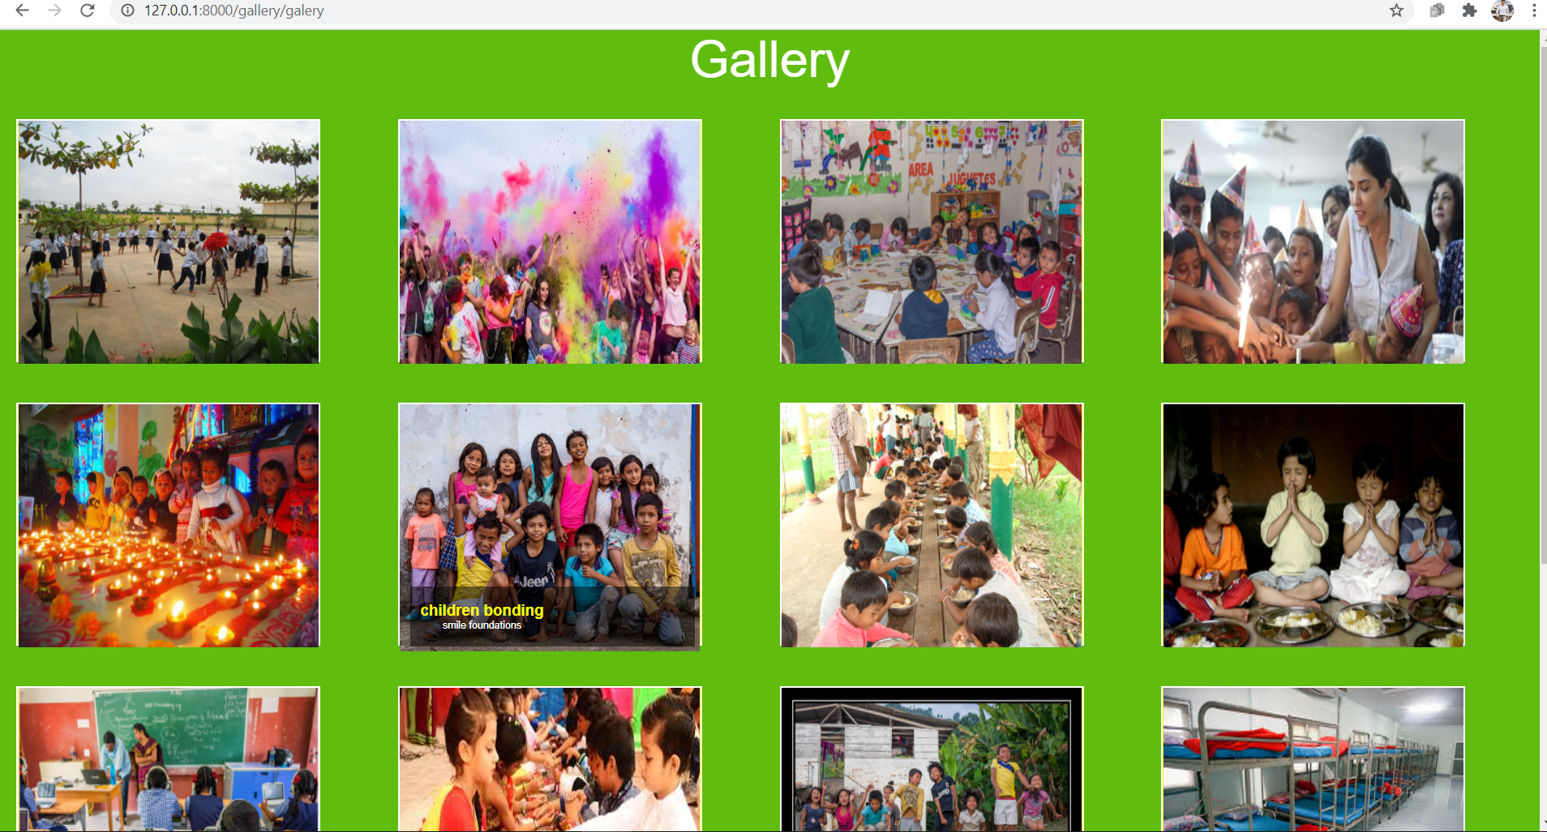

BACKEND PART OF GALLERY:

All the orphanage home related images are uploaded by the Admin through the admin panel. At any time The Admin can update and delete the images of the gallery( in the backend).

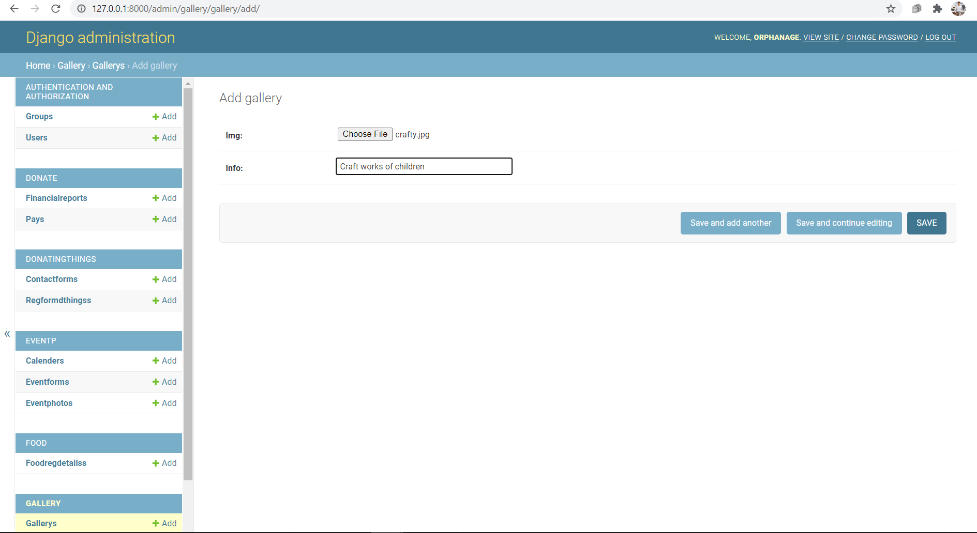

This “gallery” function is to receive web request from user and redirect to the gallery of the

website(web response)

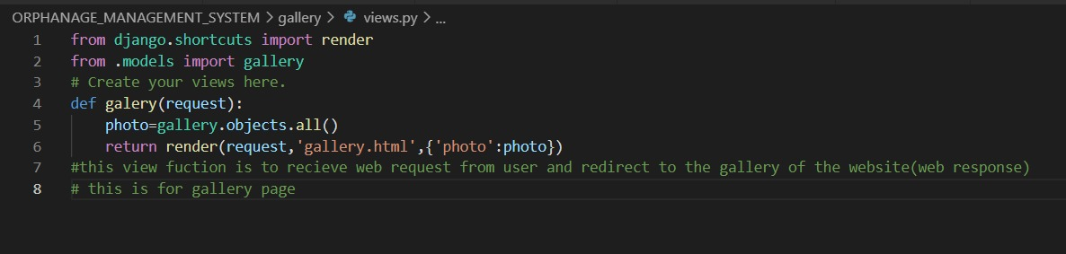

This "gallery" class in models.py represents tables or collection in our database for gallery page of our

website

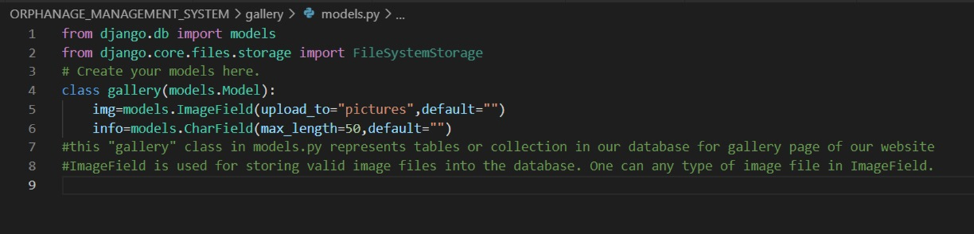

SPONSOR A CHILD:

After Clicking the SPONSOR button in the navigation bar of the home page . It will take the user to the sponsor page.

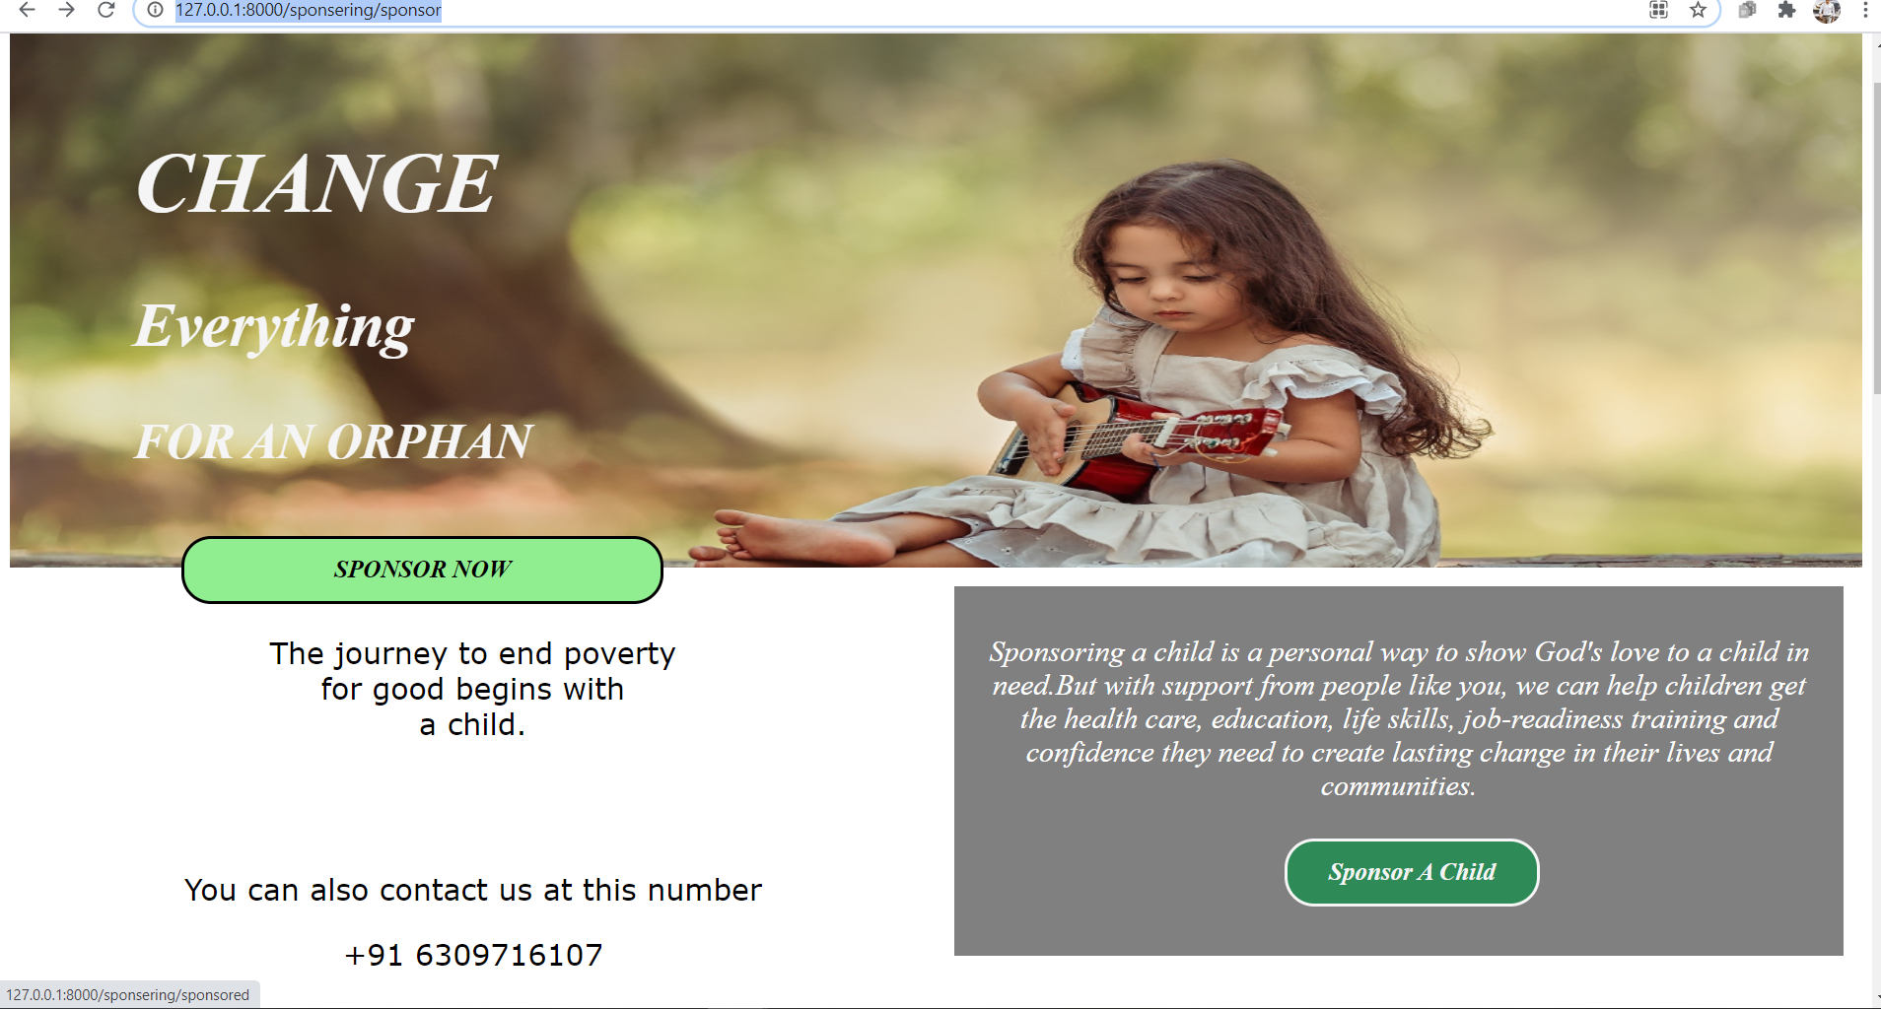

After clicking the Sponsor Now button it will takes the user to the sponsoring form which asks the user to fill some basic details.

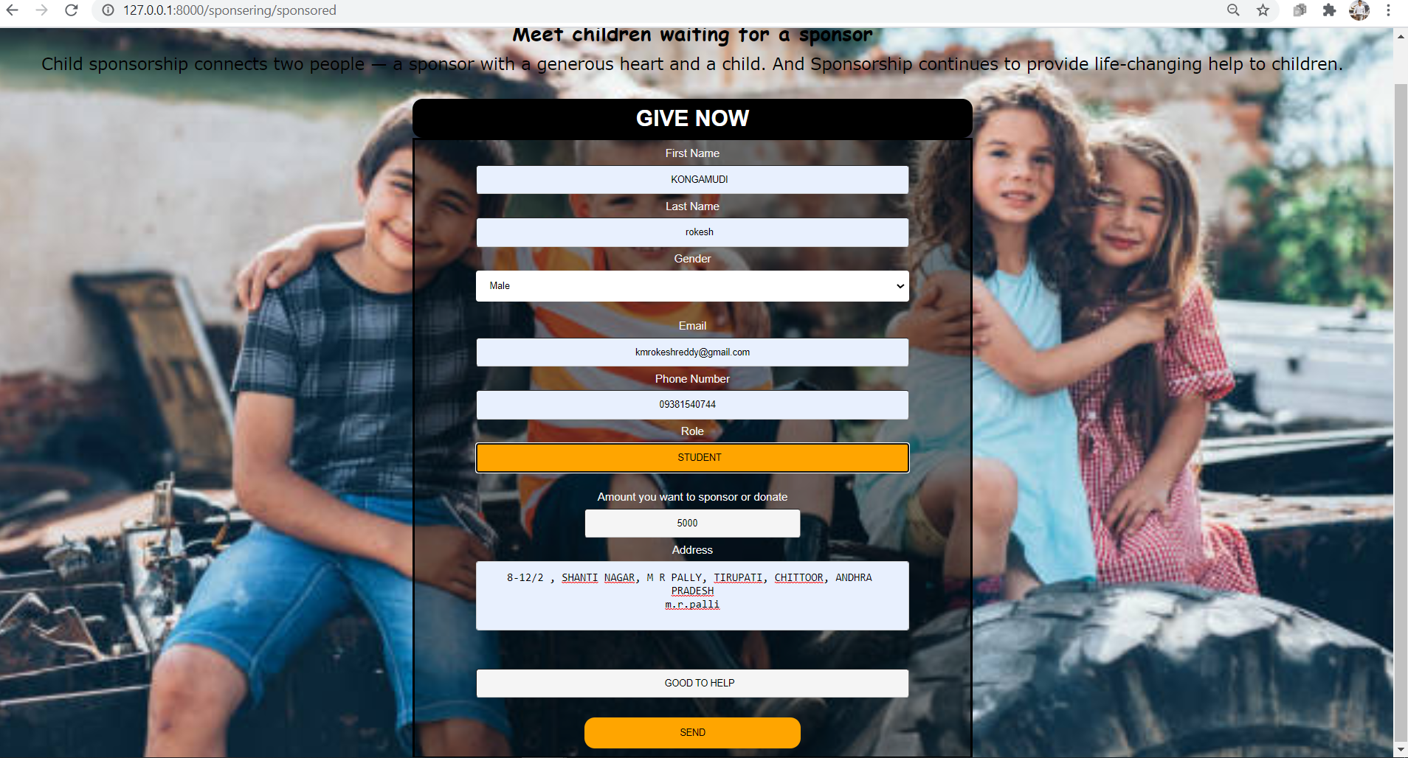

BACKEND PART OF THE SPONSOR FORM:

The entered data by the user is stored in the database of the website.

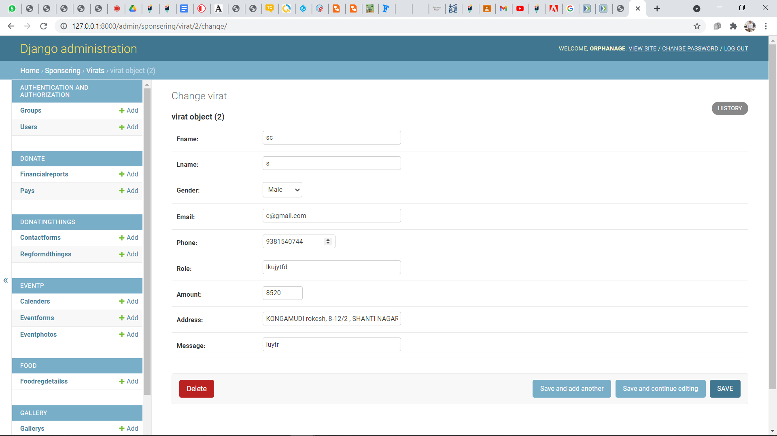

After filling the user details it will takes the user to the payment form for transactions.

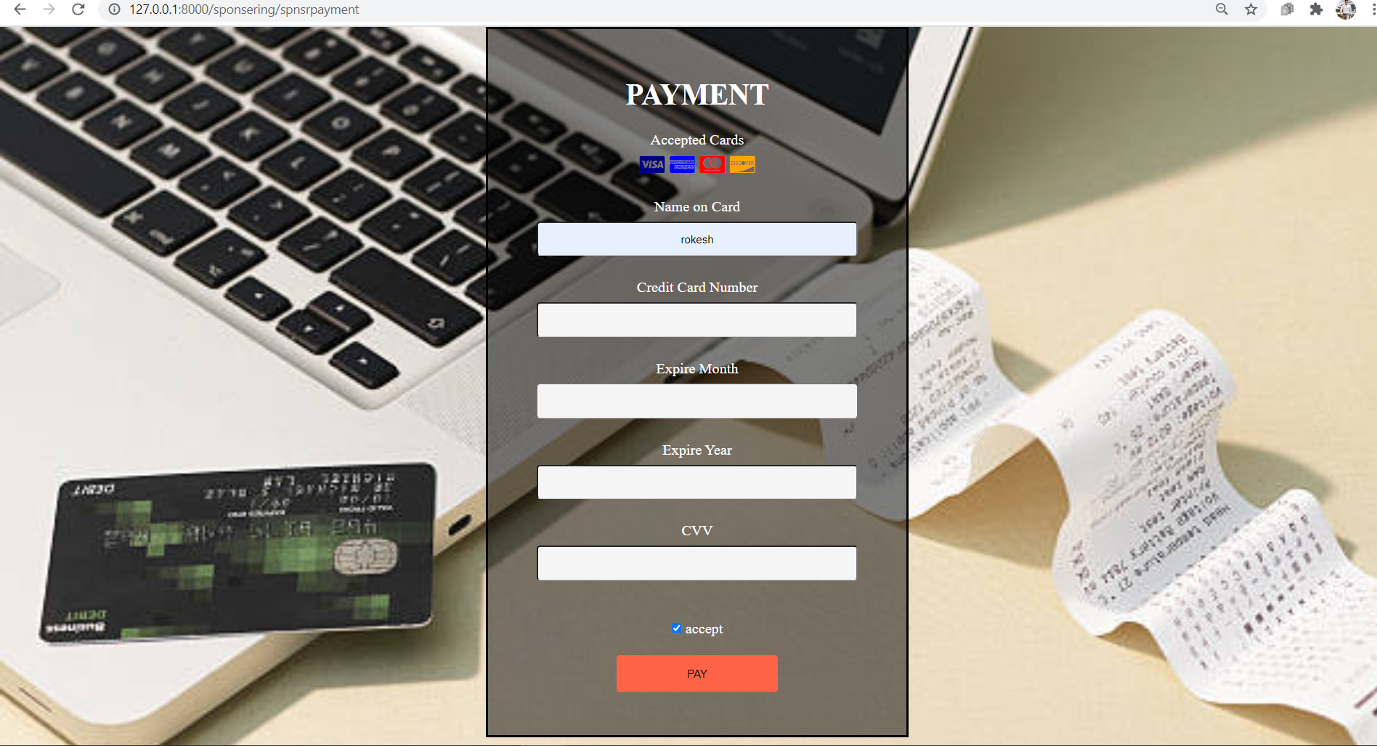

BACKEND OF THE PAYMENT FORM:

The Name of the cardholder and the card number given by the user is stored in the website database.

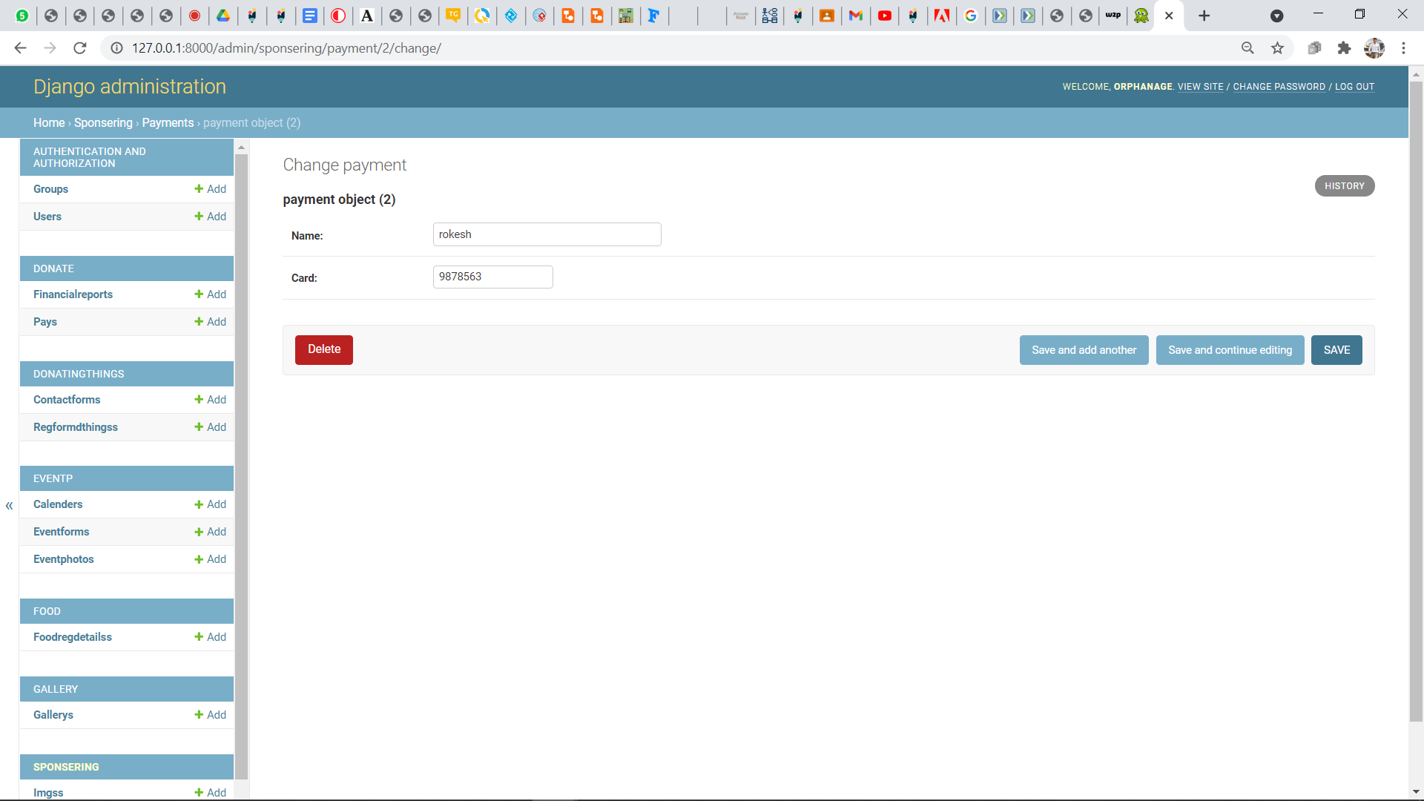

CHILDREN WAITING FOR THE SPONSORS:

The Orphanage children who are waiting for the sponsorship from the Sponsors, the images and the details are uploaded in this page. After clicking the SPONSOR NOW button it will take the user to the sponsor form where sponsor can fill the details and start sponsoring the child.

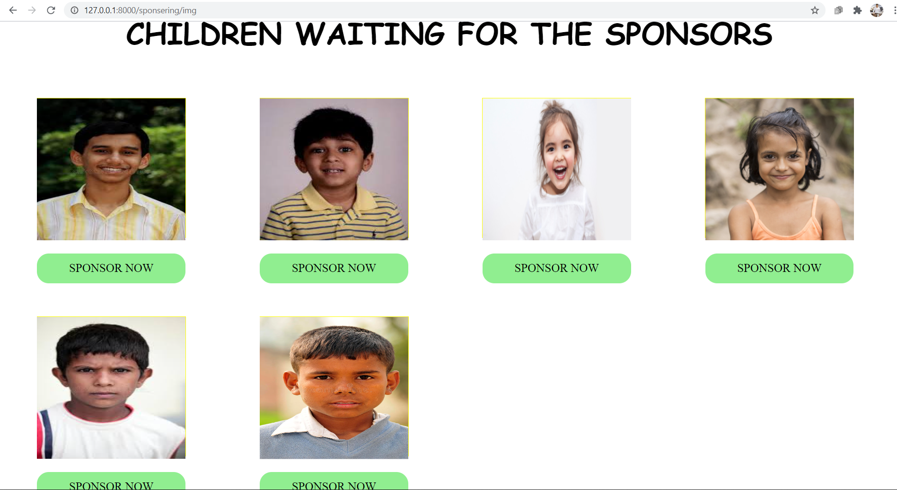

BACKEND PART:

The images and the details of the children in the orphanage who are waiting for the sponsors are uploaded to the website from the backend.

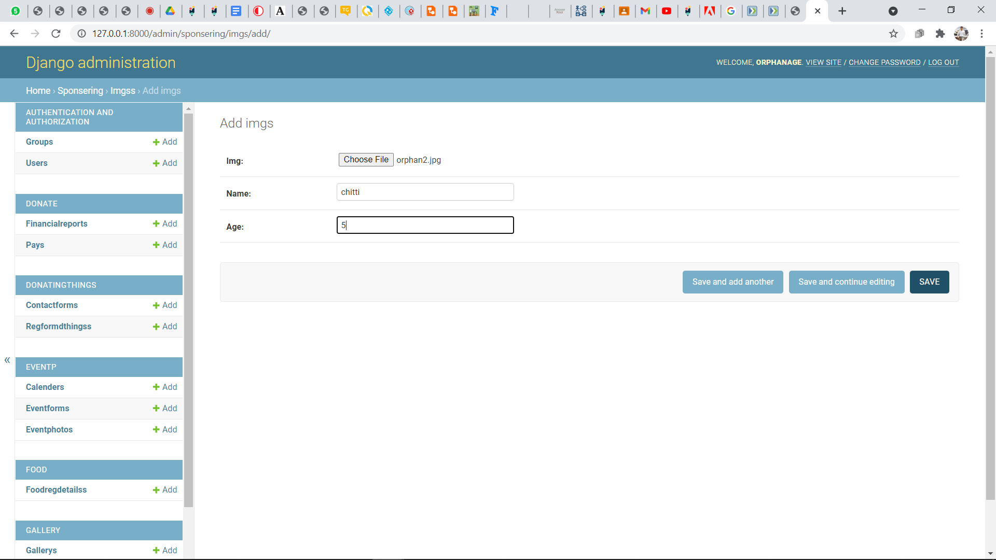

This view “sponsor” is to recieve web request from user and redirect to the sponsor main page of the website(web response) .This “sponsored” is to recieve web request from user and redirect to the sponsoring details page of the website(web response)

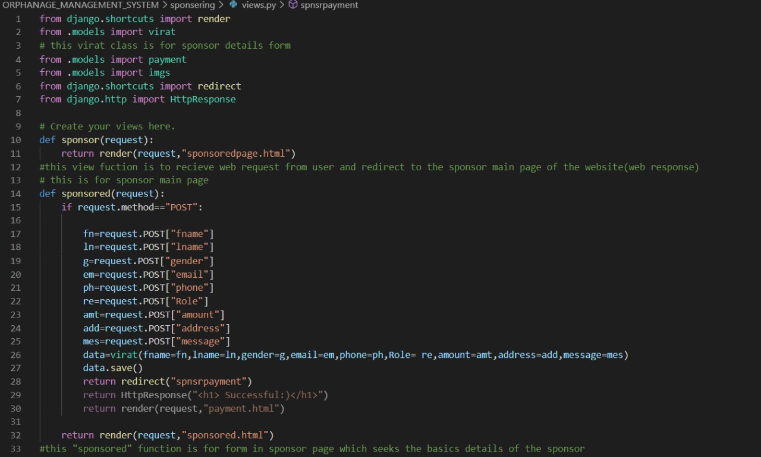

This view “sponsoring” function is to receive web request from user and redirect to the sponsoring details page of the website(web response) 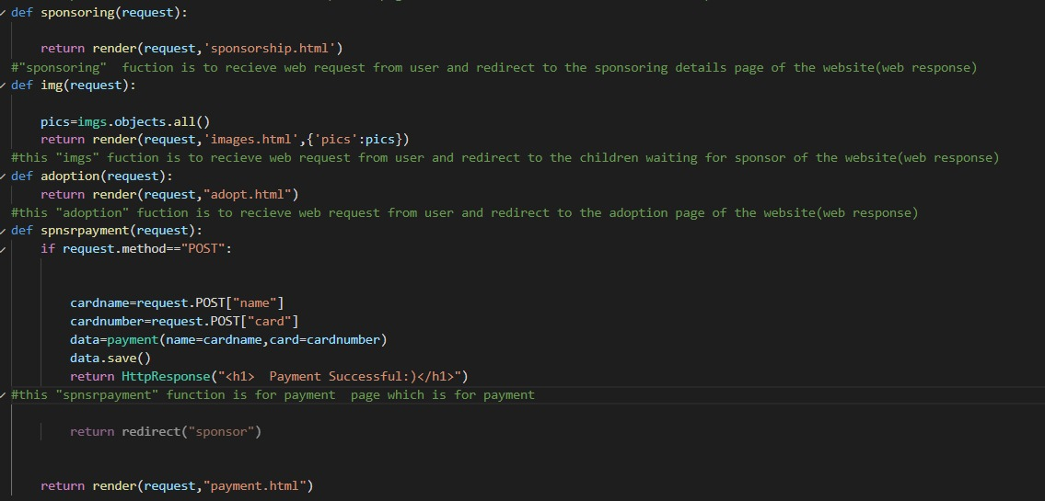

Function “img” for the page children for the sponsor, "adoption" function is to receive web request from user and redirect to the adoption page of the website(web response)

"spnsrpayment" function is for payment page which is for payment

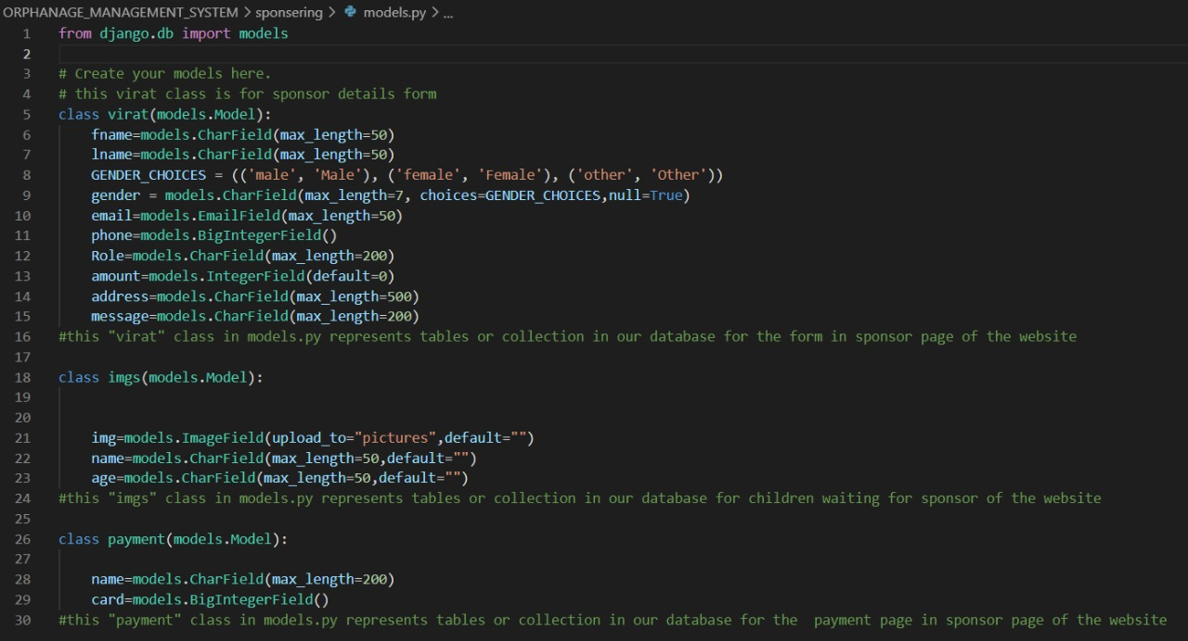

"payment", "virat" and "imgs" classes in models.py represents tables or collection in our database for the form in sponsor page,children waiting for sponsor and payment page in sponsor page of the website

DONATING THINGS:

By clicking the DONATING THINGS button in the navigation bar the website will take the user to the donating things page. The detailed information of which things can be donated to the orphans is displayed on the website. The users who want to donate things through the courier can donate by finding the postal address on the website.

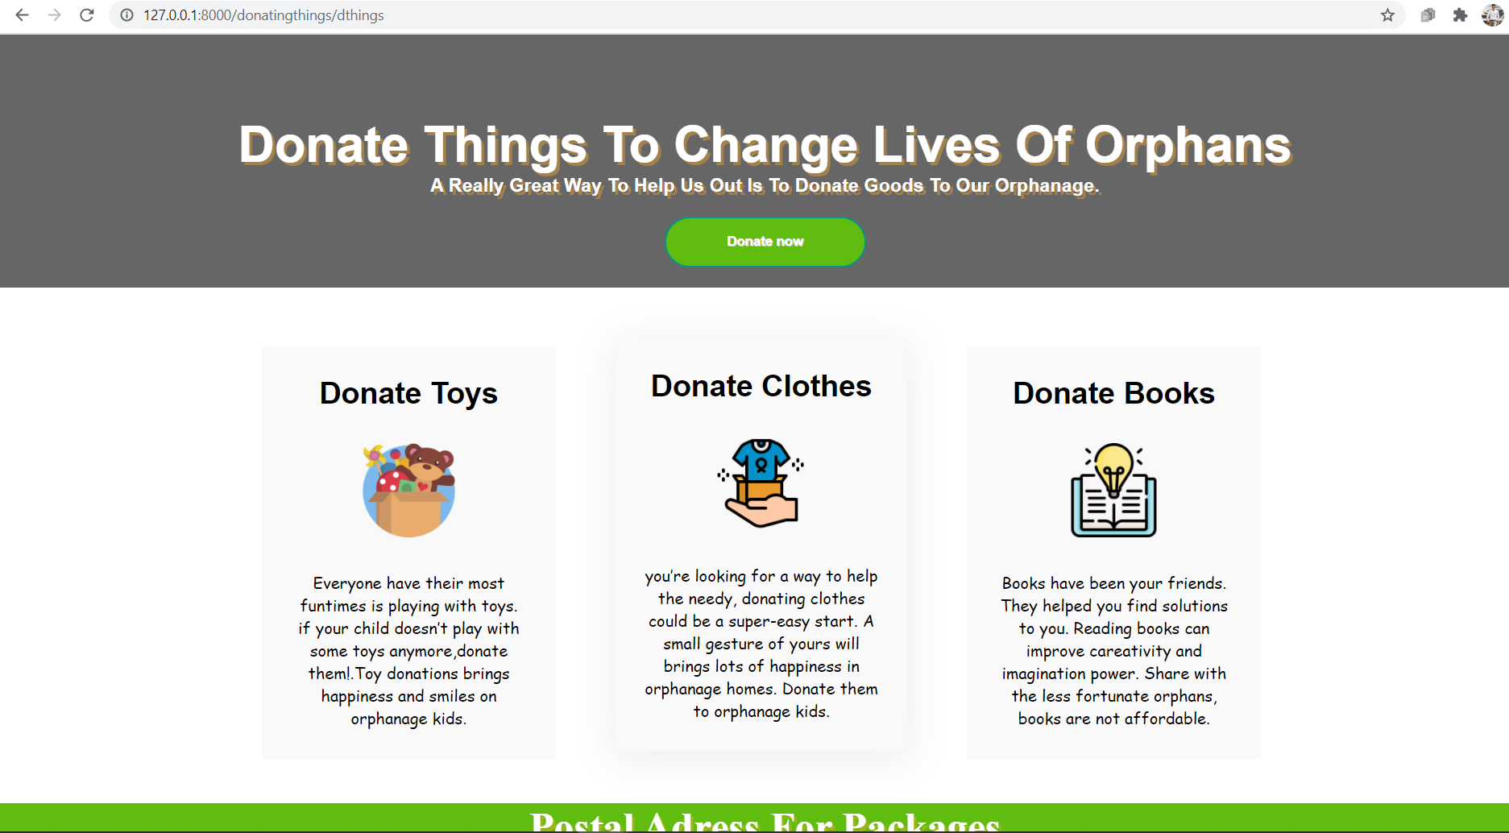

By clicking the DONATE NOW on the donating things page it will take the user to the donating things form. By giving the basic details of the donating things to the form the user can successfully donate the things to the orphanage.

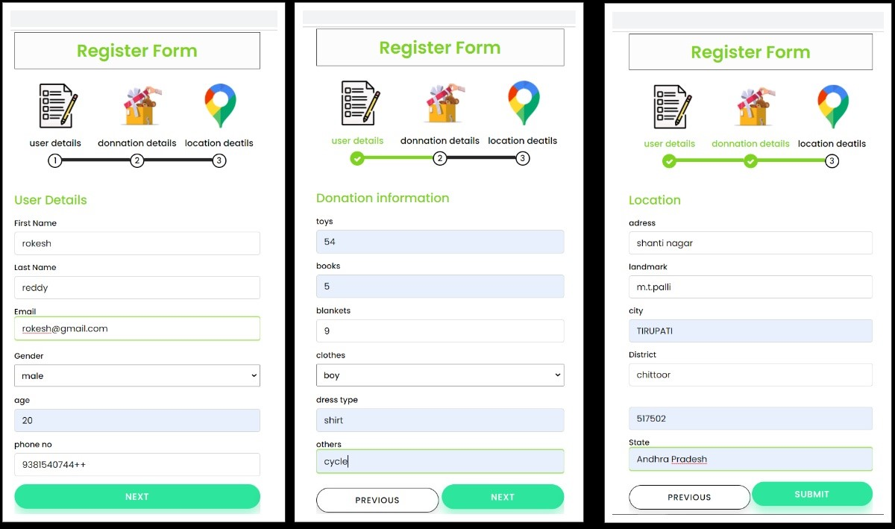

BACKEND PART OF THE DONATING THINGS FORM:

All the details given in the form by the user will be stored in the website database.

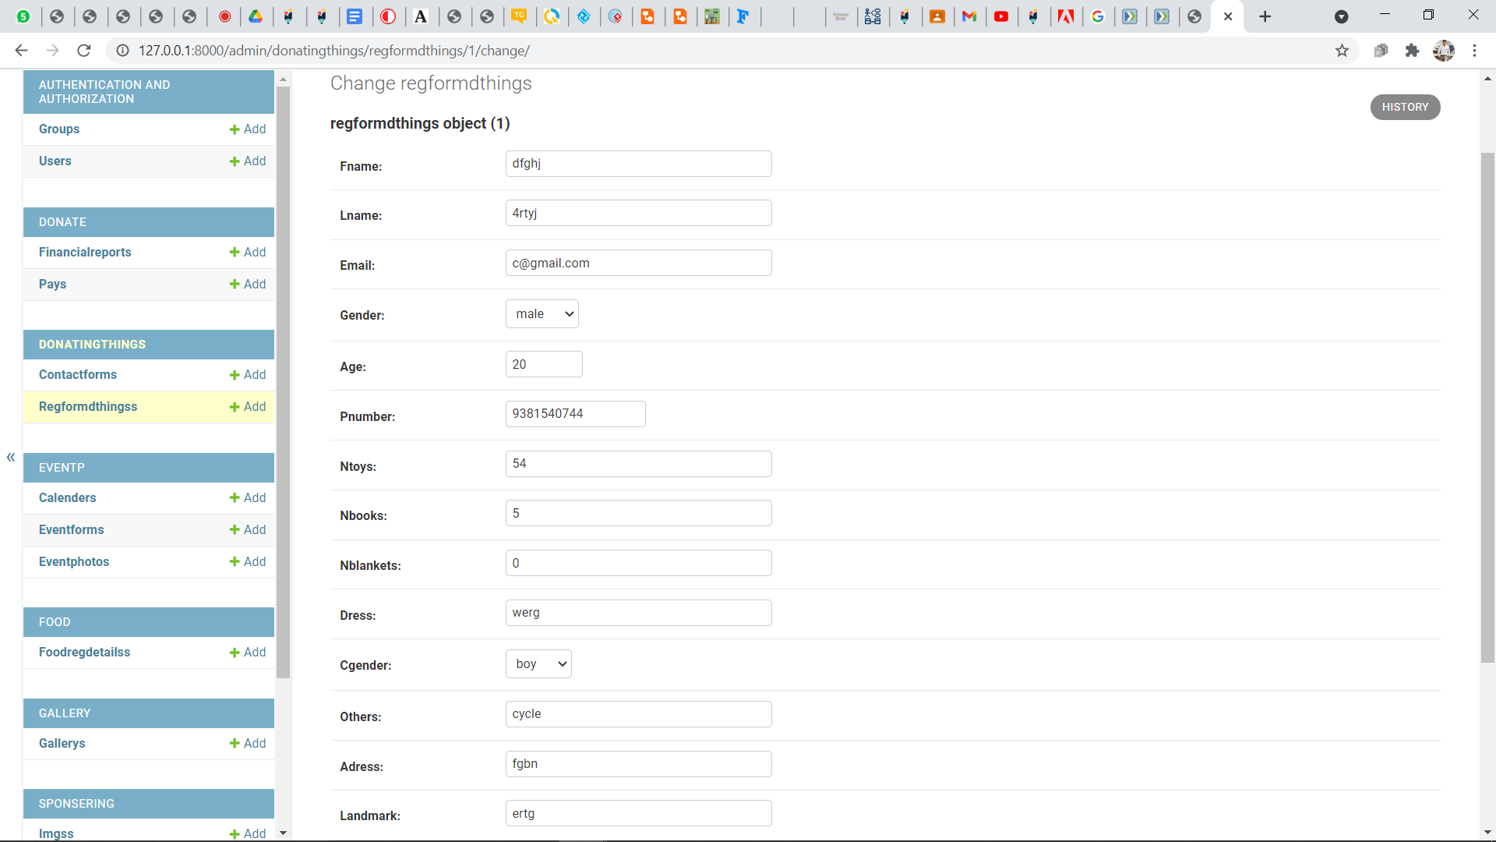

“dthings”function is to receive web request from user and redirect to the donating things page of the website(web response). "dtreform" function is for form in donating things form page which seeks the basics details for donating things.

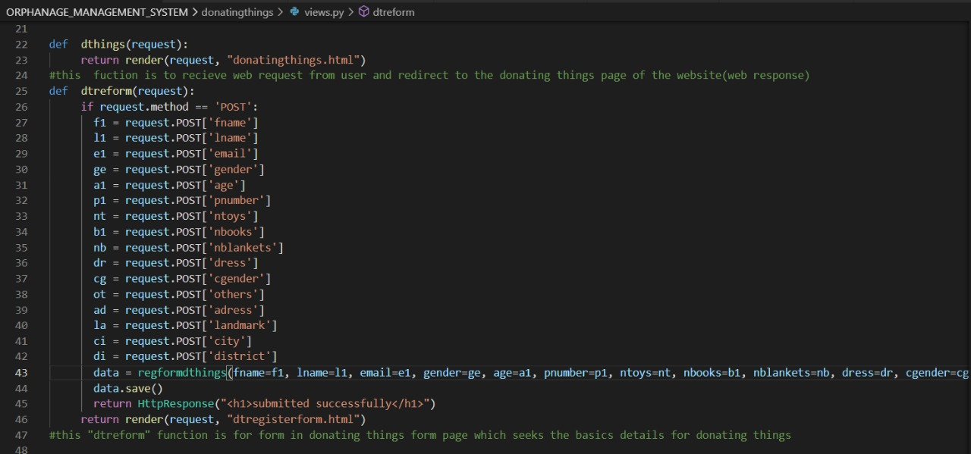

"regformdthing" class in models.py represents tables or collection in our database for the form in donating things page of the website

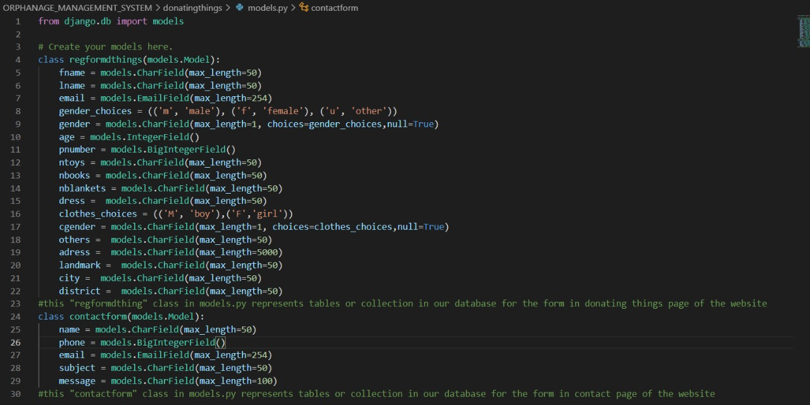

ADOPTION:

By clicking the ADOPTION button in the navigation bar it take the user to the adoption page . In this page the user can find the guidelines for the adoption of an orphanage child. Website provides the contact details, those who interested can contact.

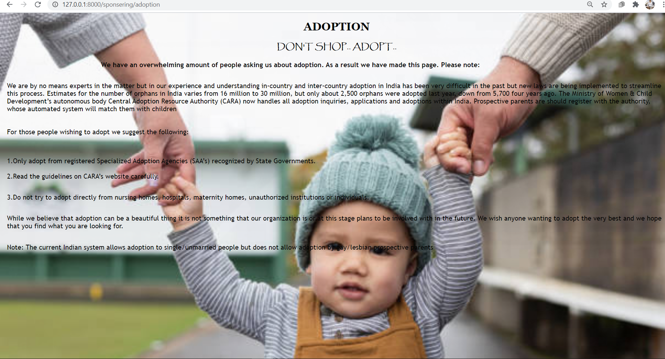

CONTACT PAGE:

By clicking the CONTACT button on the navigation bar it take the user to the contact page. In this page the user can ask any queries related to the orphanage details and any further queries.

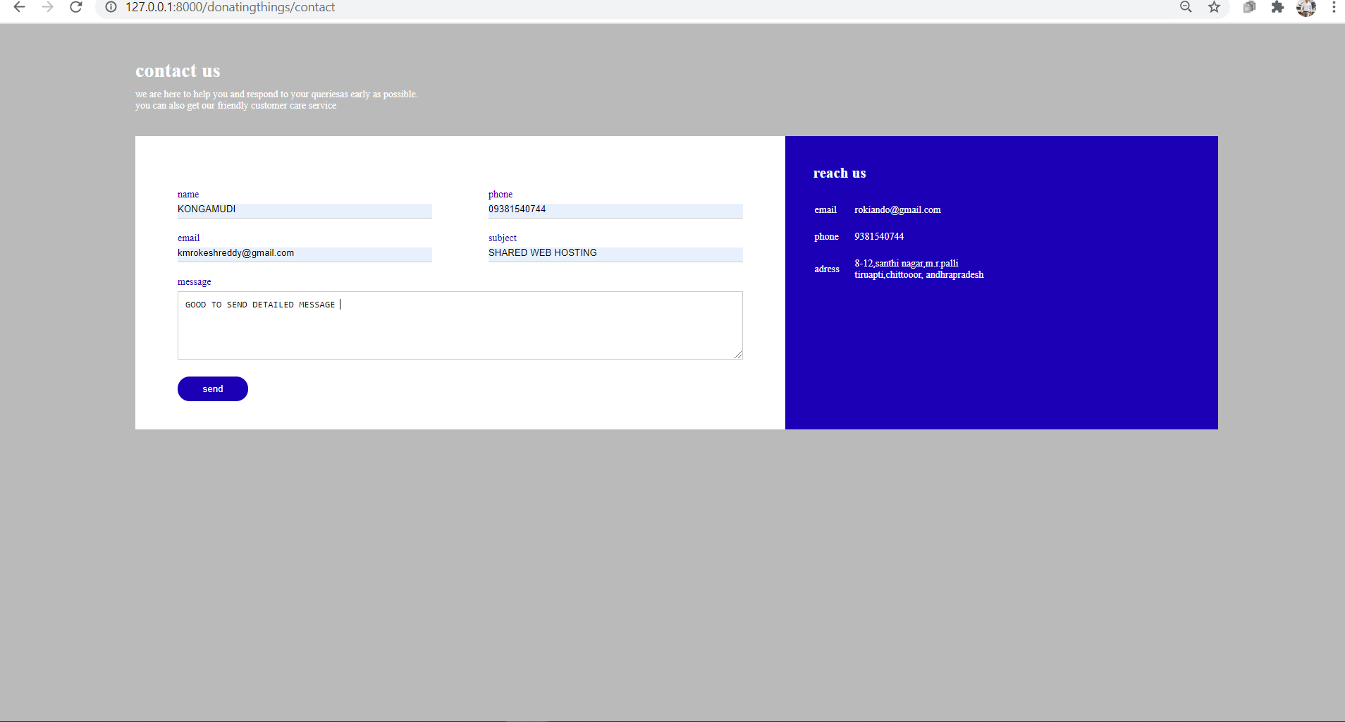

BACKEND PART OF THE CONTACT PAGE:

The queries asked by the user in the contactus page are in the database of the website.

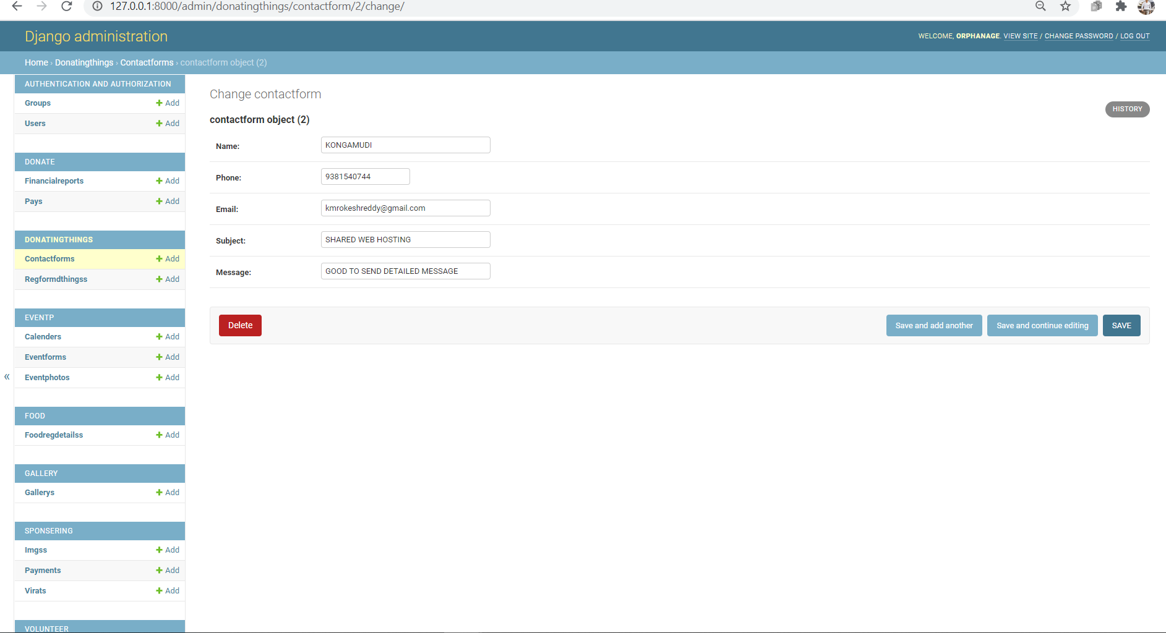

"contactform" class in models.py represents tables or collection in our database for the form in contact page of the website

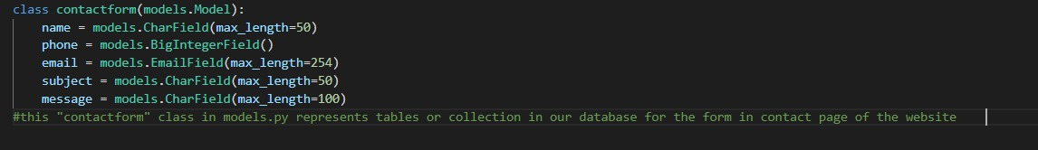

"contact" function is for contact form page which seeks the queries of users about the website

function is to receive web request from user and redirect to the donating things page of the website(web response)

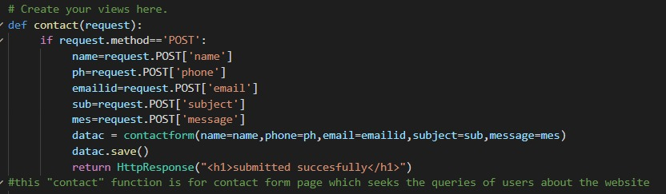

SURPLUS FOOD:

By clicking on the SURPLUS FOOD button on the navigation bar it take the user to the surplus food page.

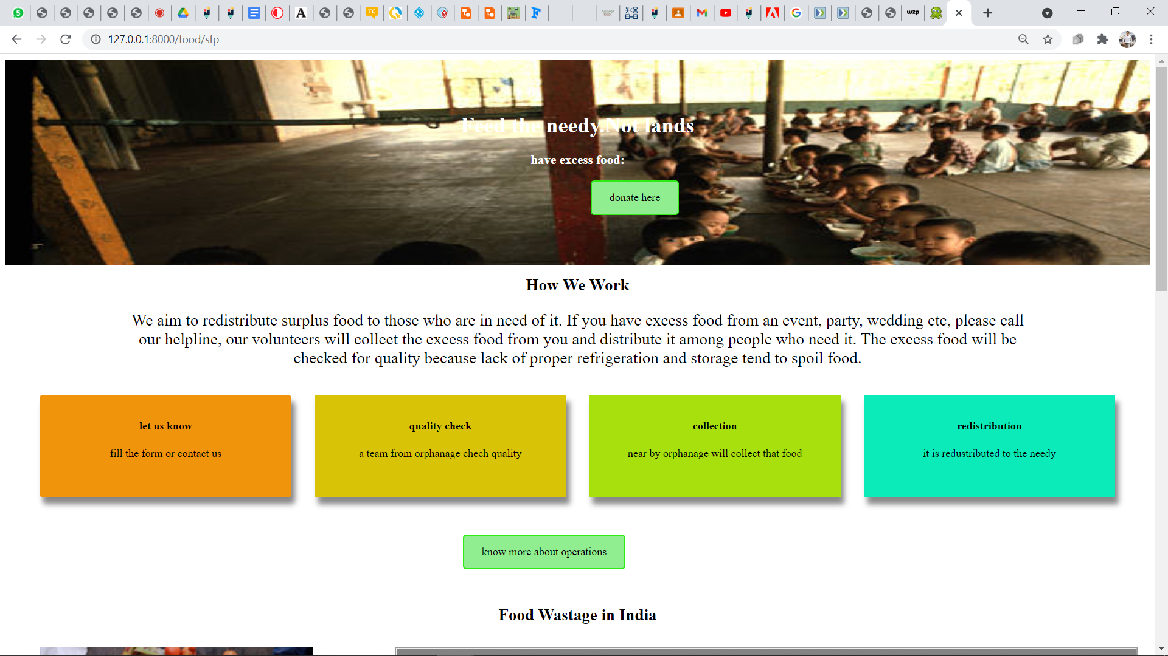

We aim to redistribute surplus food to those who are in need of it. If any user has excess food form an event, party, wedding etc.. They can donate to the orphanages nearer to them by clicking the DONATE HERE button. After clicking the donate here button it will take the user to the page where the user is asked to fill the basic details of the form. In this the user’s location (latitudes and longitudes) are traced and distance is calculated to the nearby orphanage with which we are collaborated. The food is collected by the nearby orphanage team if and only if the food distance is less than 100km.

The nearby orphanage details is shown like an alert message after clicking the button PRESS HERE TO GET THE NEARBY ORPHANAGE. If the distance is greater than 100km then website will show an alert message that “ you are out the server”. If anyone skips the some details it show an alert msg that the data must be filled.

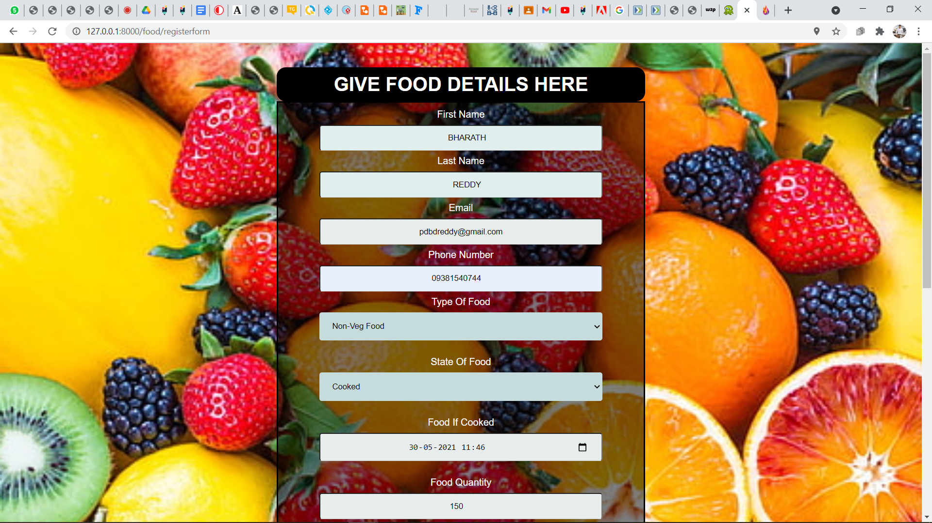

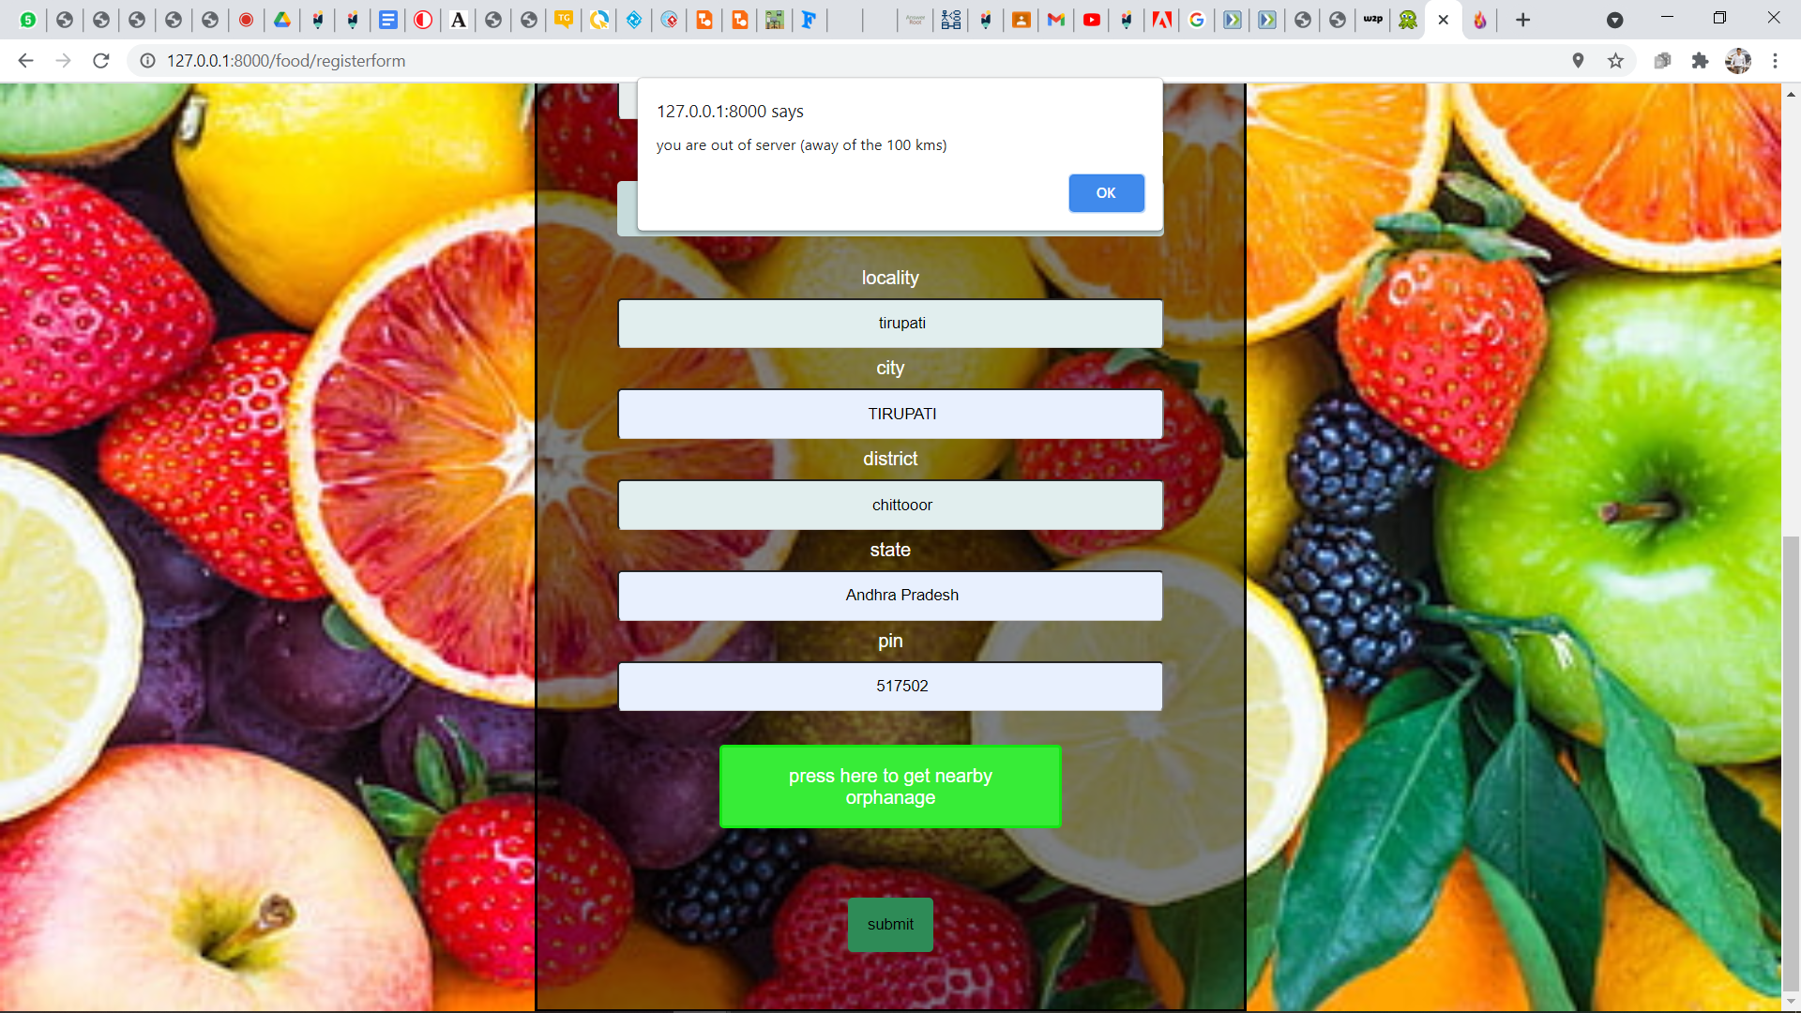

BACKEND PART OF SURPLUS FOOD:

The entered data of the surplus food by the donor is stored in the database of the website.

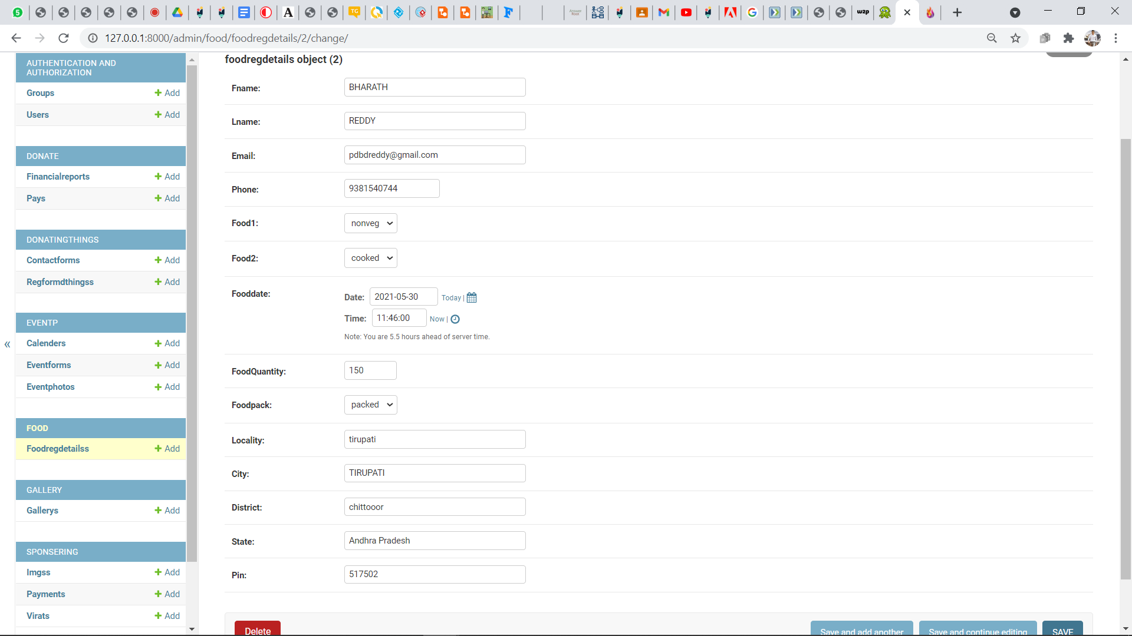

These are the collaborated orphanage homes that we are working for. By clicking the Don’t waste donate instead it will take the user to the page which the guidelines of the food donation is displayed.

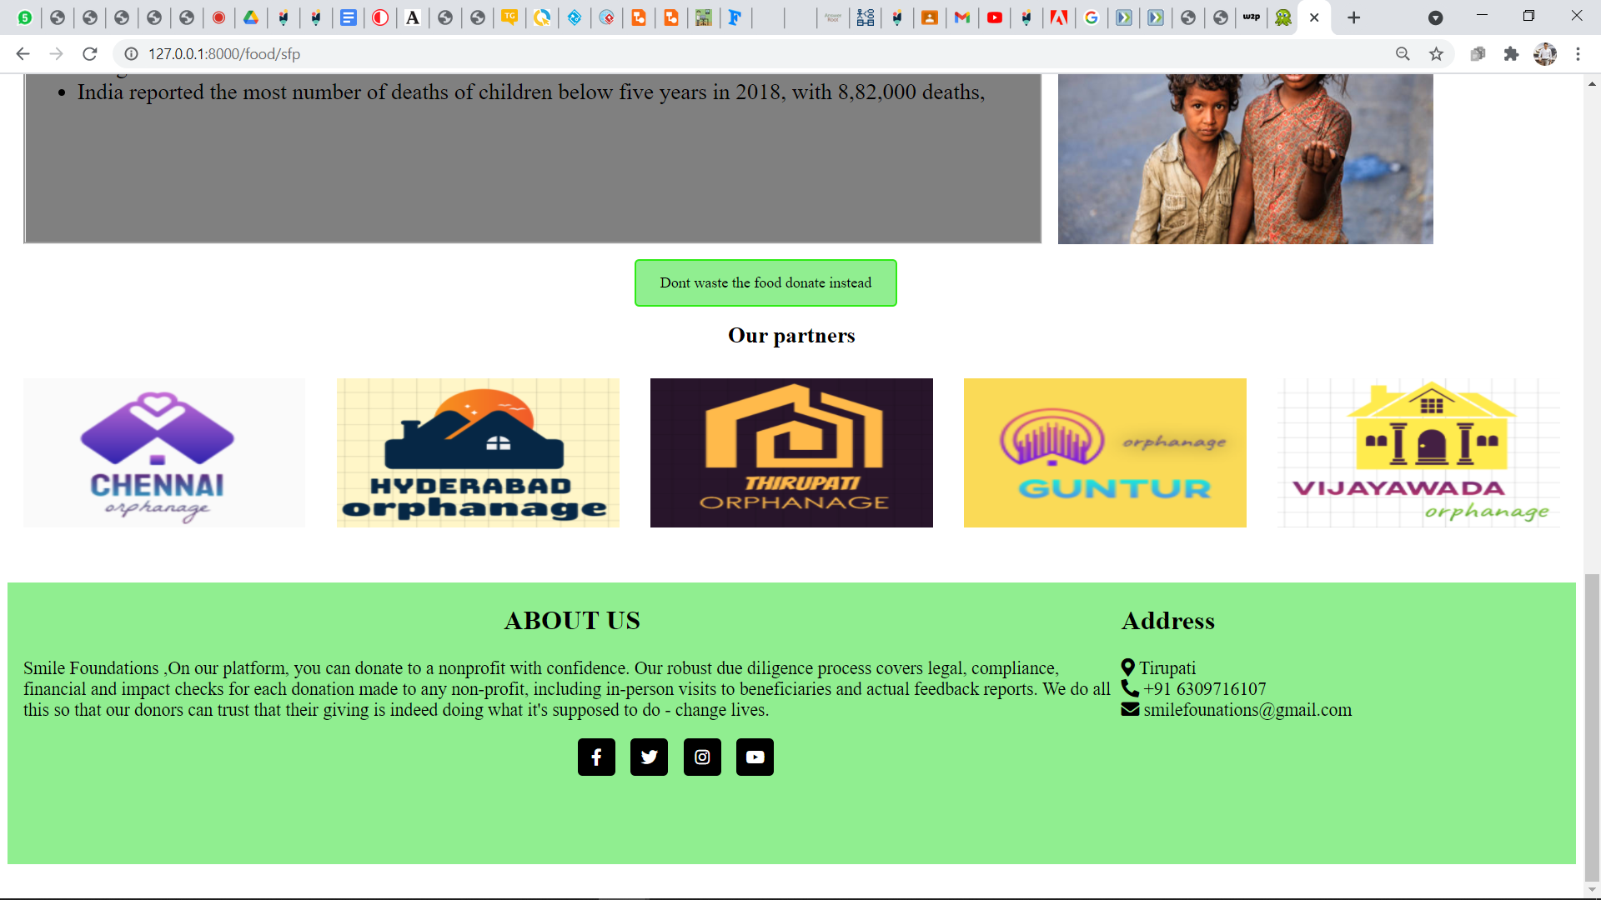

FUNCTION “sfp” is for surplus food page

FUNCTION “moreinfo” is for more information on food page .(guidelines of food donation )

FUNCTION “operations” is for operations page,”registerform” is for food details form.

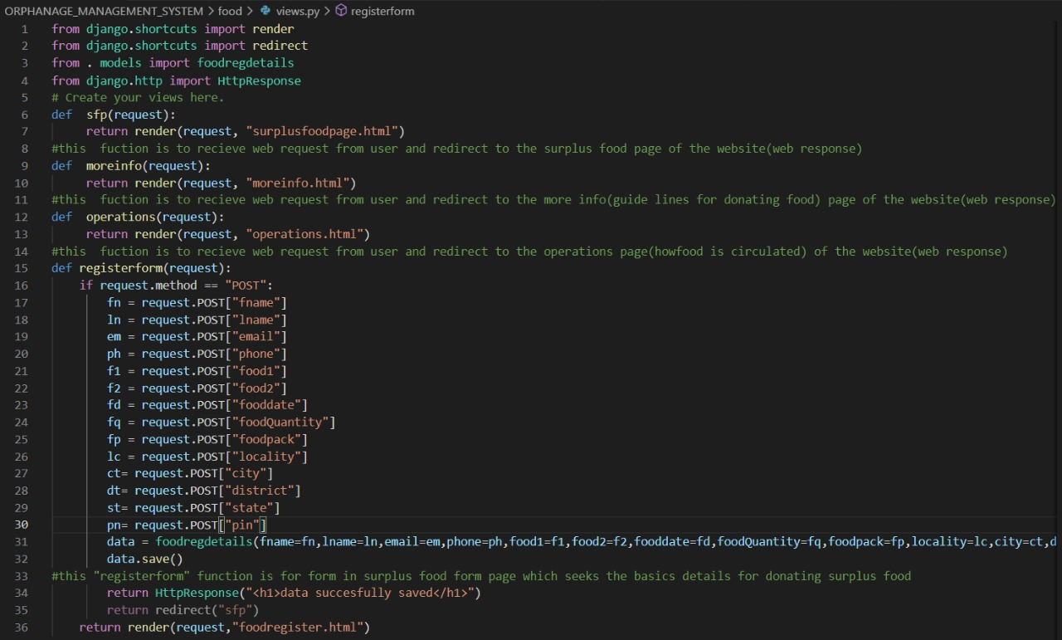

“foodregdetails” model class is for food details form Database.

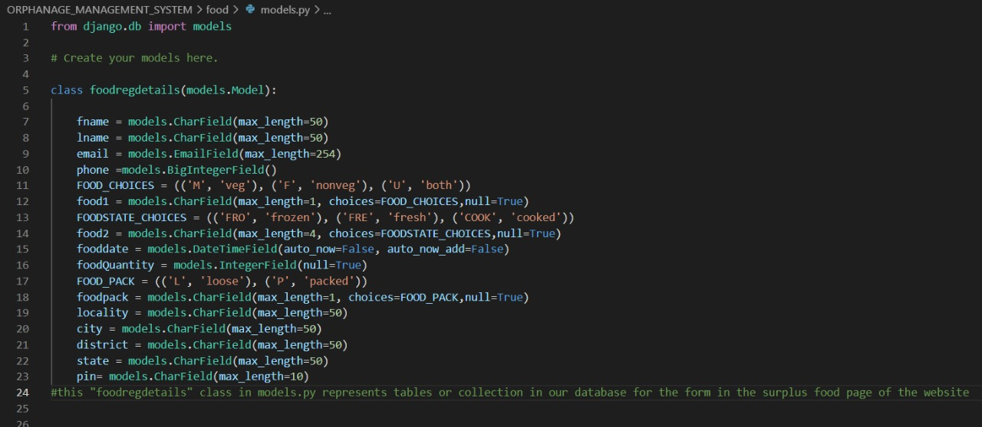

VOLUNTEERING:

By clicking on the VOLUNTEER button on the navigation bar it will take the user to the volunteer page of the website. In the volunteer page the user will find the article “LIFE AS A VOLUNTEER IN THE ORPHANAGES HOMES”.

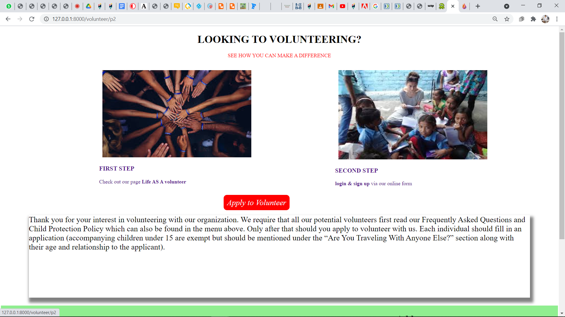

By clicking the APPLY TO VOLUNTEER button it will take the user to volunteer registration form. By filling the details the user can register as a volunteer and work for the orphanage home.

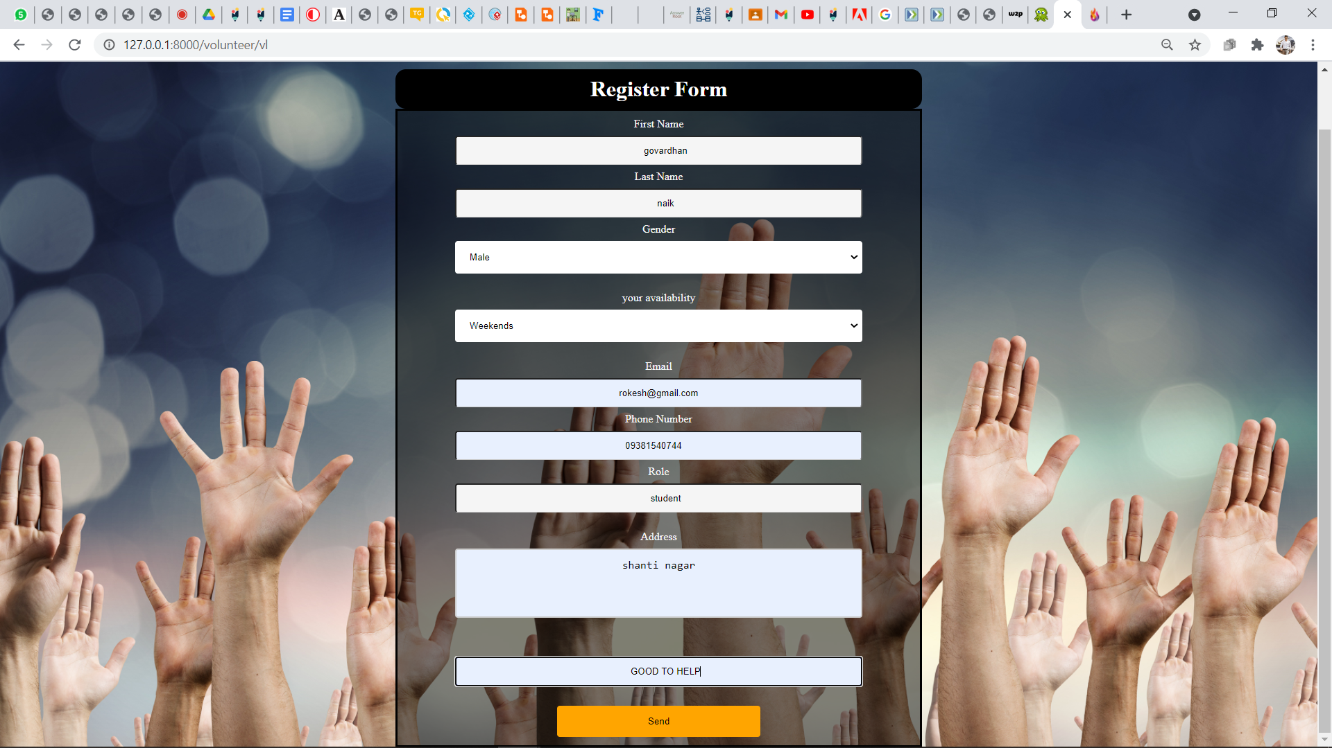

BACKEND PART OF VOLUNTEER:

The entered details of the user in the volunteer registration form are stored in the database of the website.

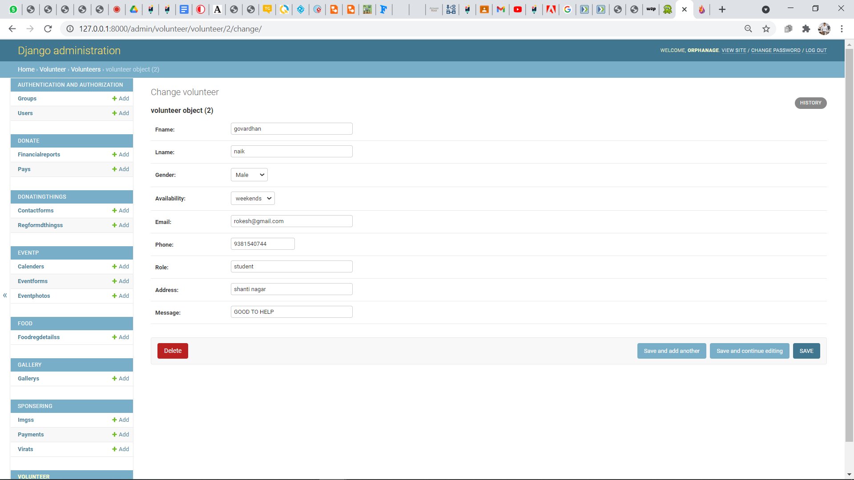

Function “p2” is for Volunteer Page.

Function “vl” is for Volunteer registration form.

Function “ragava” is for Life as Volunteer Page.

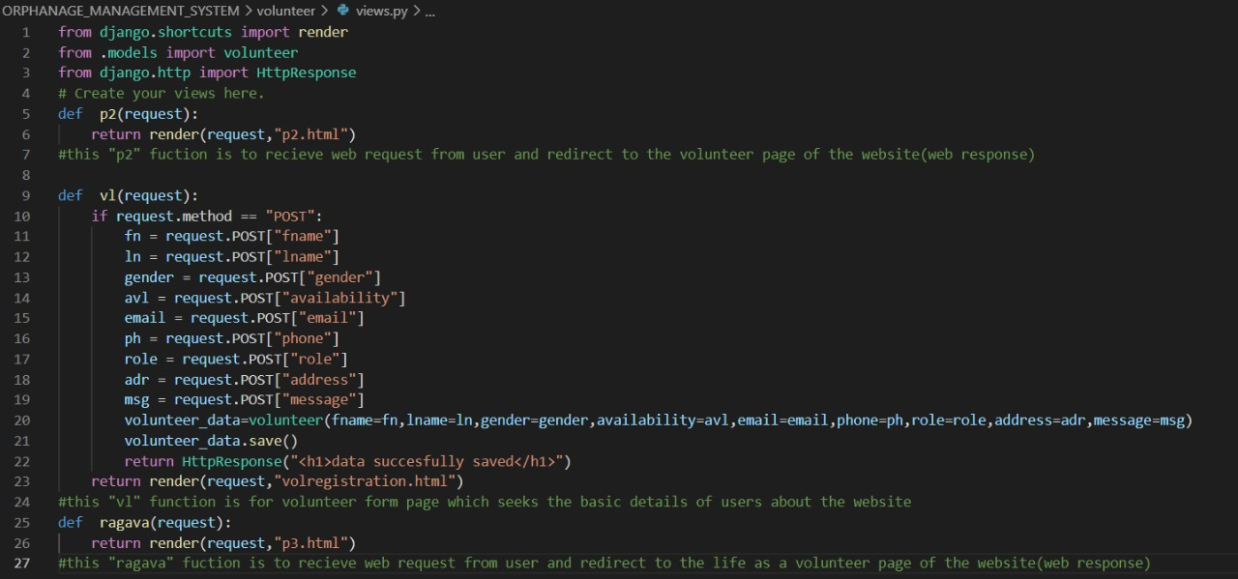

“volunteer” model class is for Volunteer form Database.

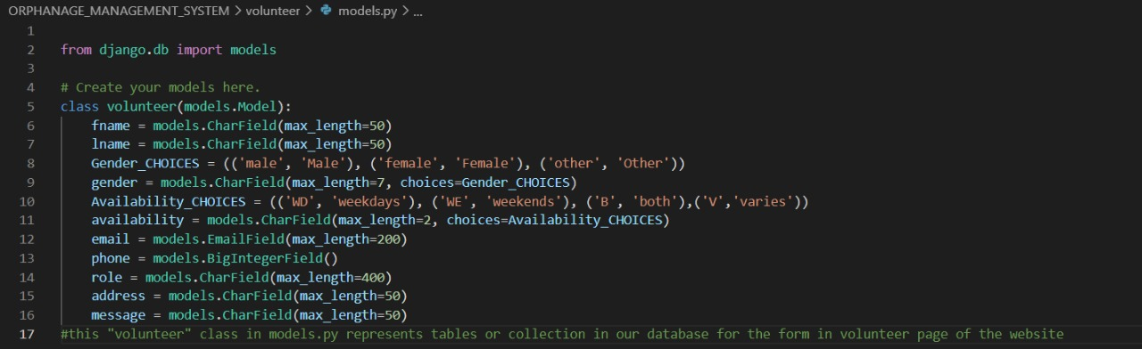

EVENT CELEBRATIONS:

By clicking the EVENT button on the navigation bar it will take the user to the EVENT CELEBRATIONS page. People who are willing to celebrate their events in the orphanage they can register through our website. By clicking the REGISTER button it will take the user to the registration form .By filling the all the mandatory details in the registration form they can register their time slot by mentioning time slot.

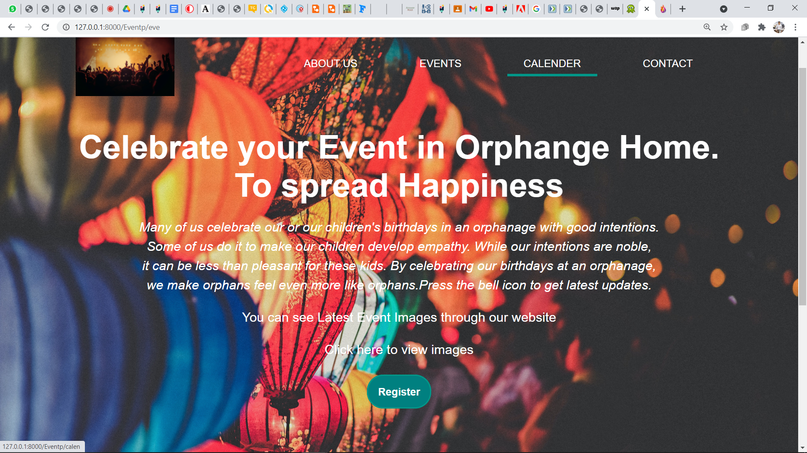

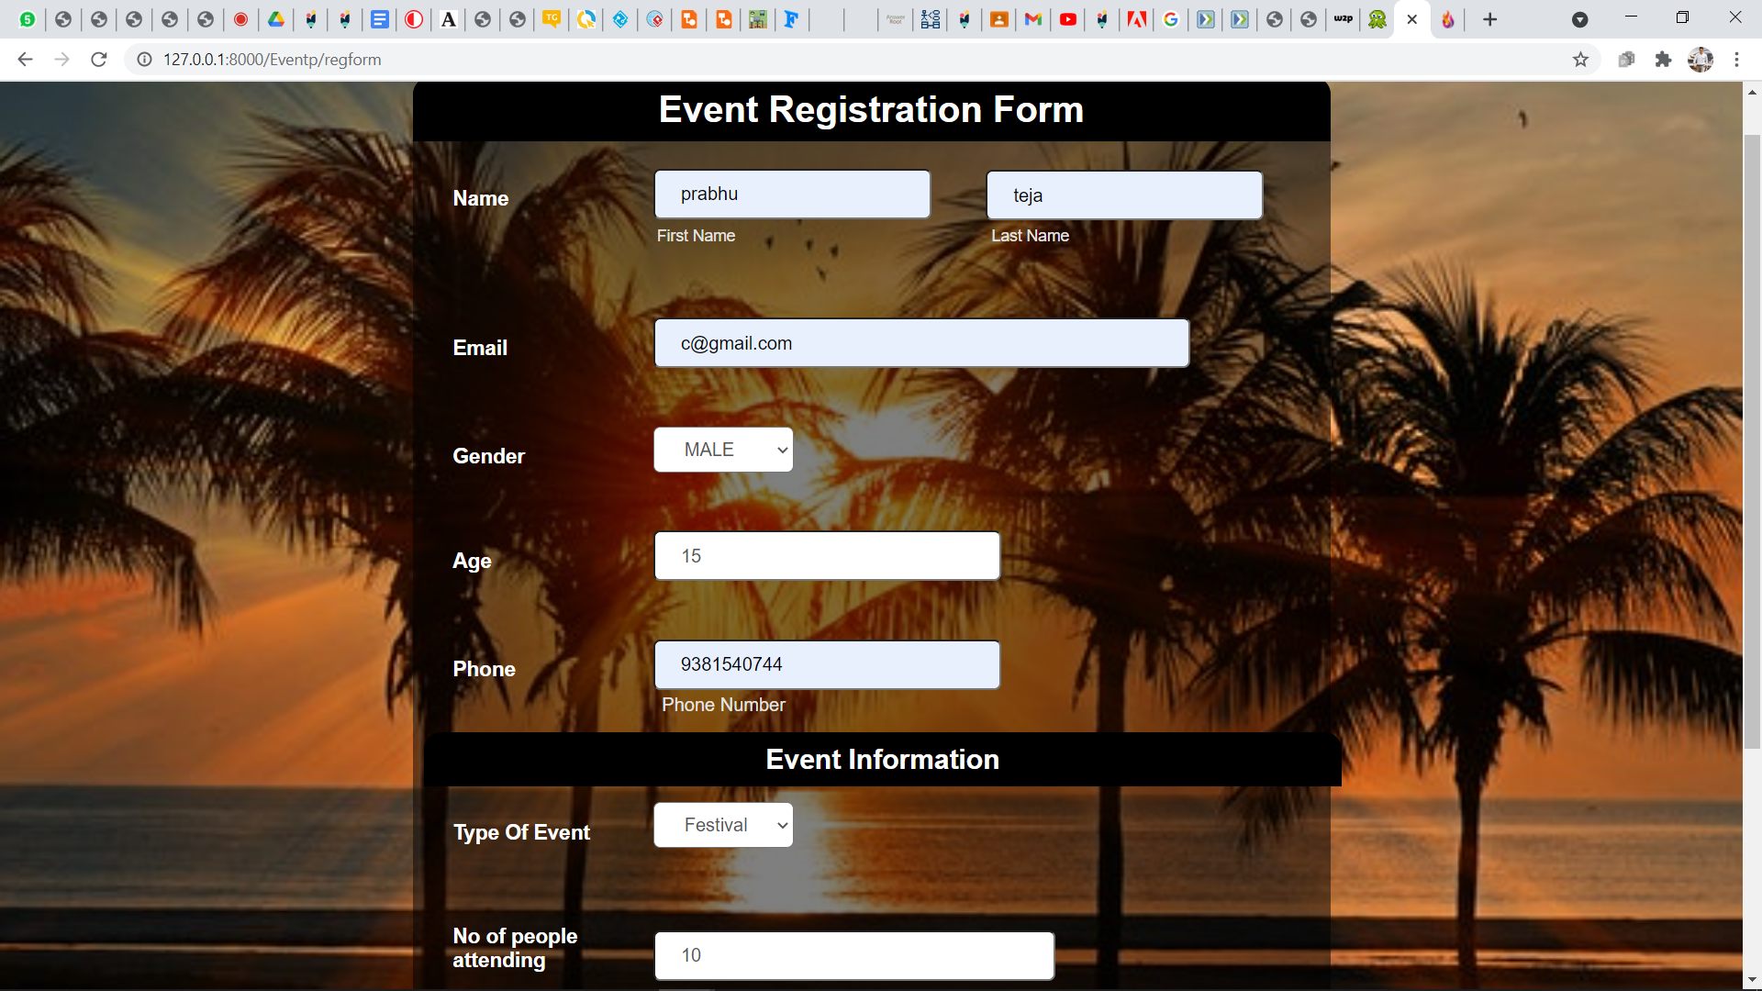

BACKEND PART OF EVENTS:

The entered details of the register form by the user is stored in the database of the website.

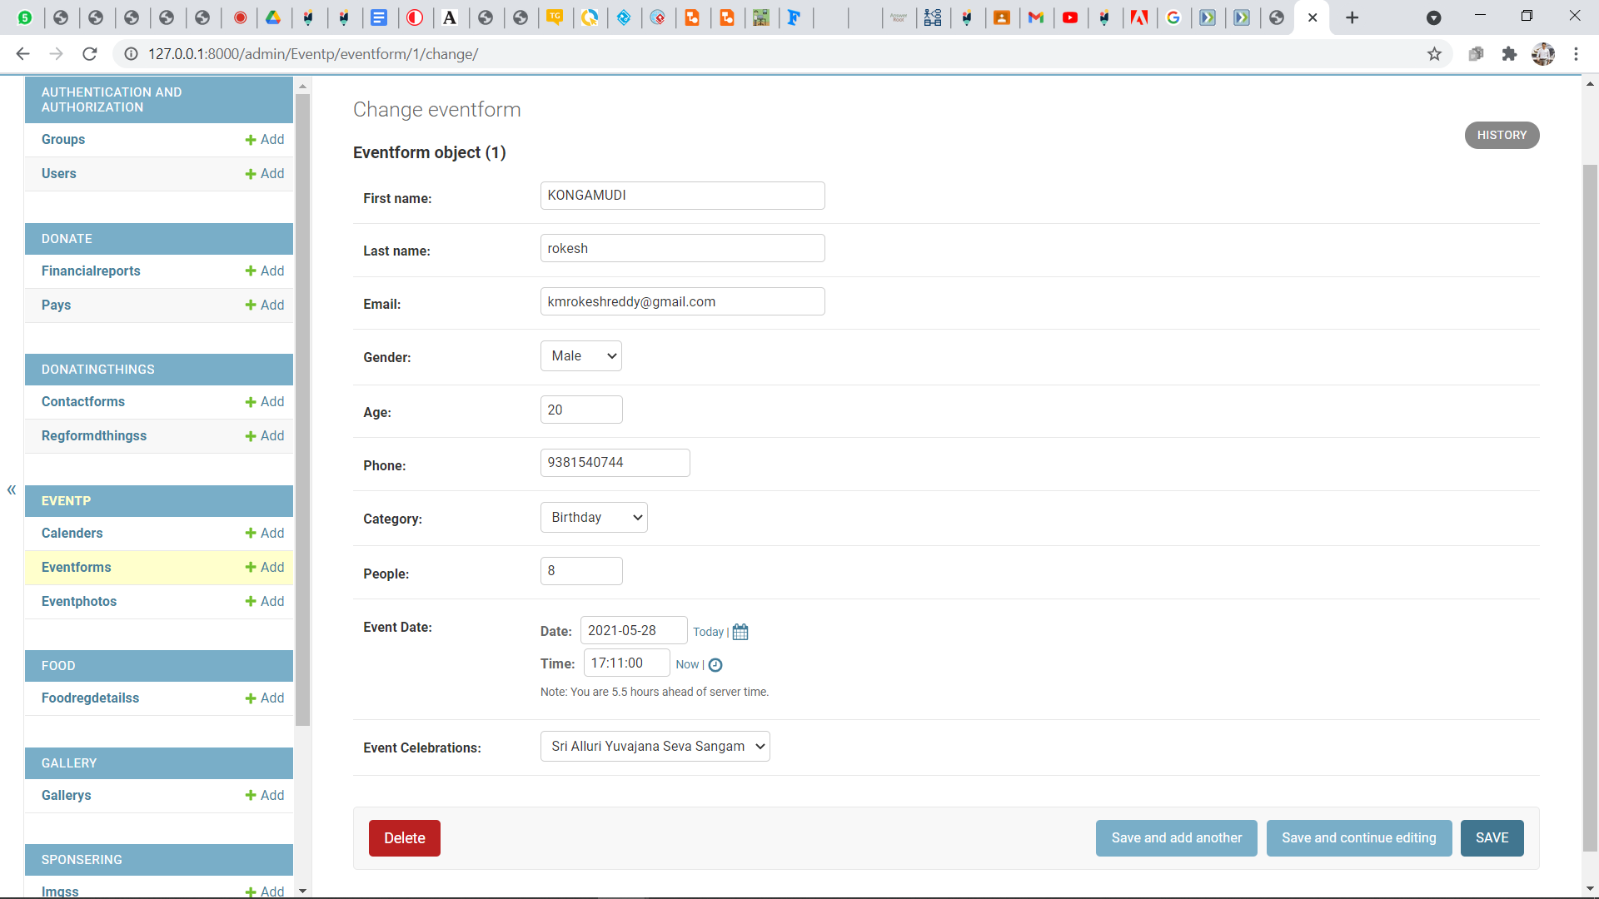

EVENT CALENDAR:

By clicking the CALENDAR button on the navigation bar it will take the user to the calendar page.

The page contains the events celebrated in the orphanages on that respective day.

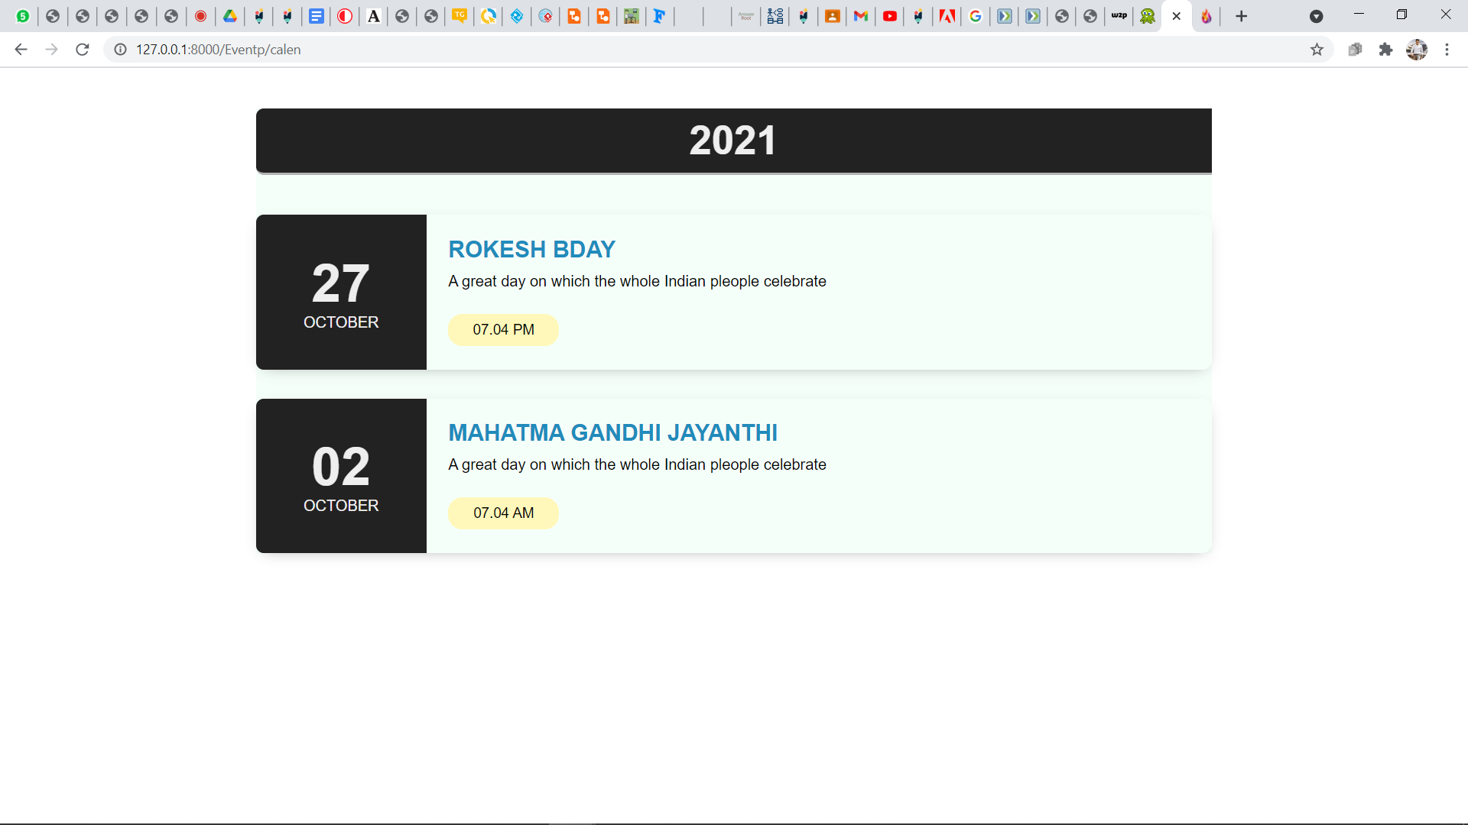

BACKEND PART OF THE CALENDAR:

The admin the update the calendar for the users to celebrate the important events.

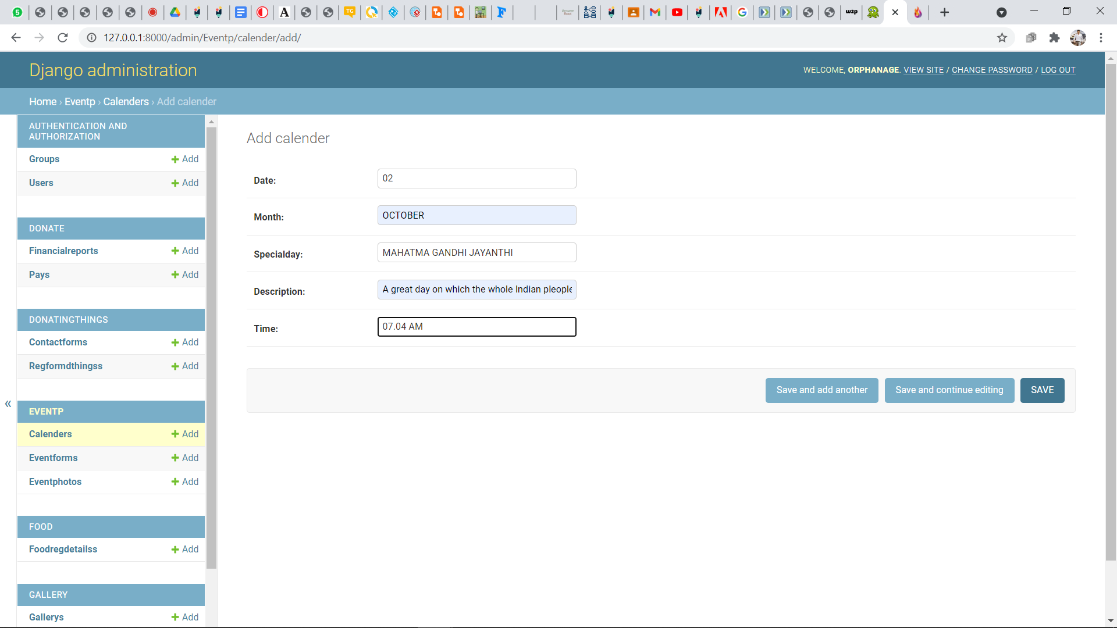

EVENTS GALLERY:

By clicking the gallery button on the events page it takes the user to the event gallery page where it show the previous events celebrated in the orphanage.

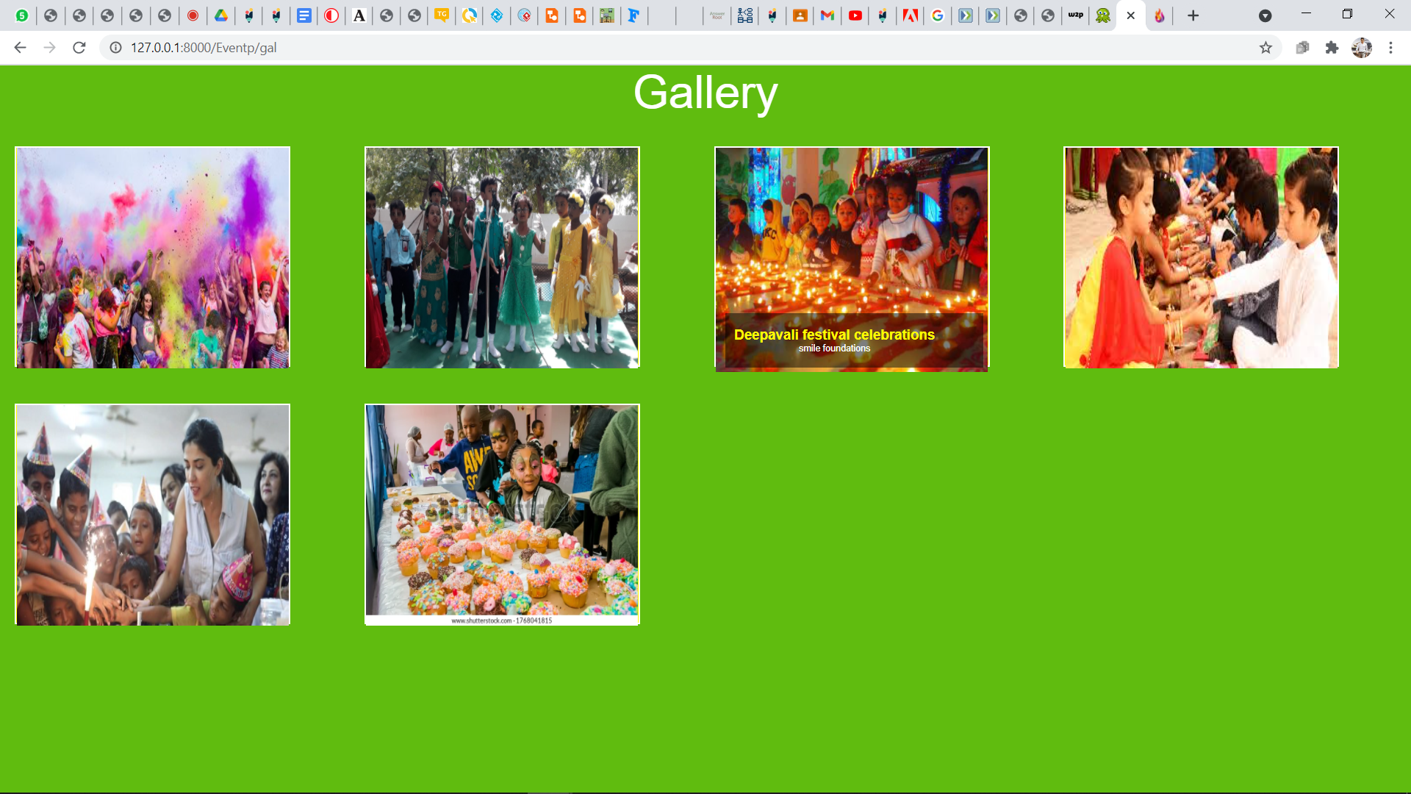

BACKEND PART OF EVENTS GALLERY:

The admin can update the events celebration photos to the event page gallery.

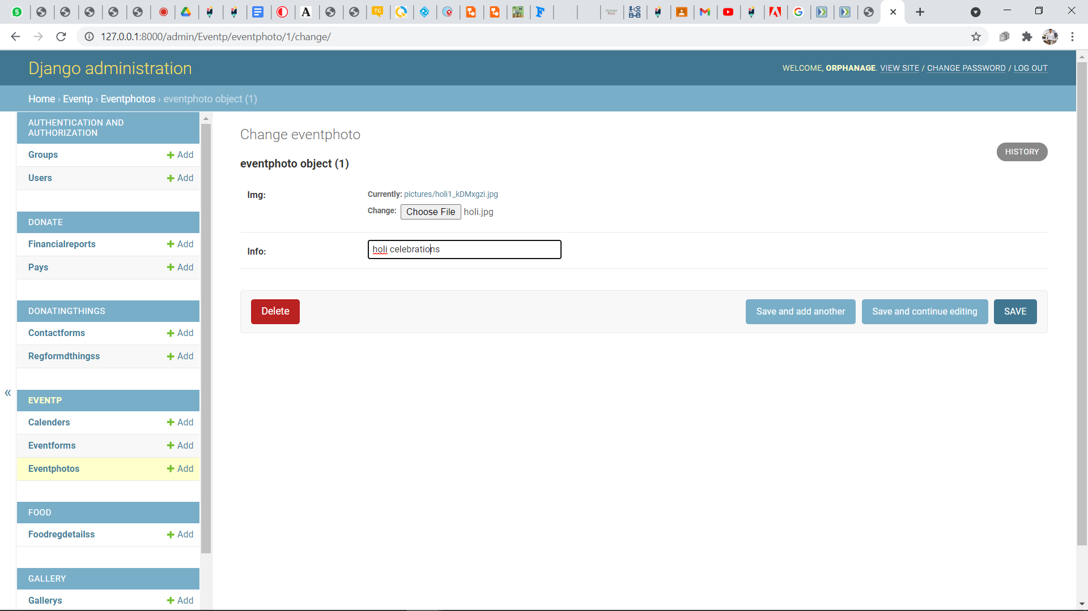

"eve" function is to receive web request from user and redirect to the event page of the website(web response), this "calen" fuction is to recieve web request from user and redirect to the event calender of the website(web response), “regform" function is for event form page which seeks the basic details of users regarding event celebration.

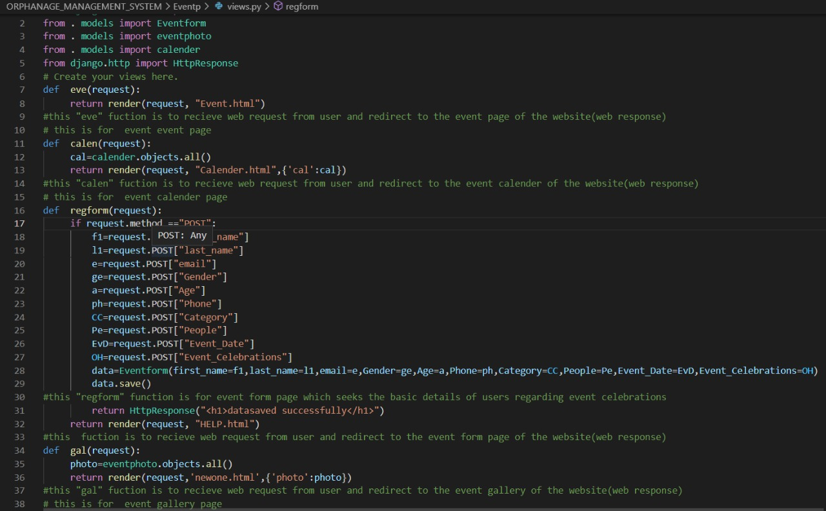

eventphoto","Eventform" and "calender" class in models.py represents tables or collection in our database for gallery page,form in event register page and in details in calender page of our website.

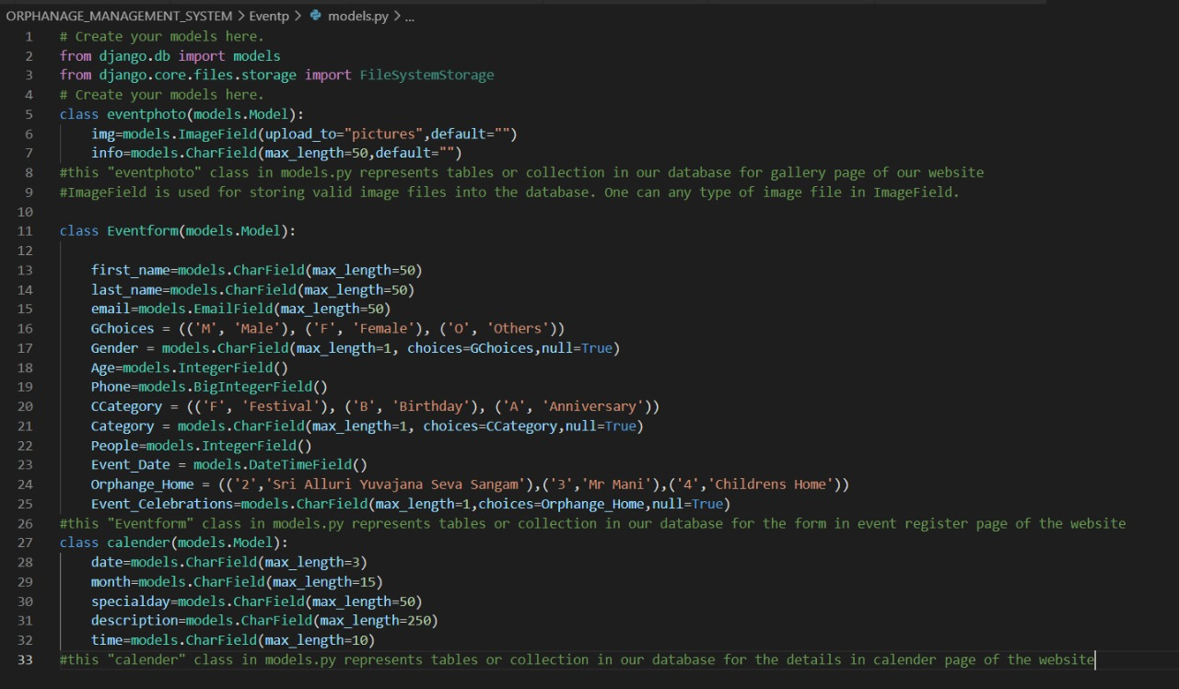

DONATE:

By clicking the DONATE button on the navigation bar of the website it will take the user to the donate page. The donation page showcase the respective years FINANCIAL reports and also AUDIT reports. And the page shows the user how the donation money used and where it goes.

PAYMENT FORM:

By clicking the DONATE NOW button on the donate page The website will take the user to the donation payment form page. Here the user should fill the payment related details in the provided payment form.

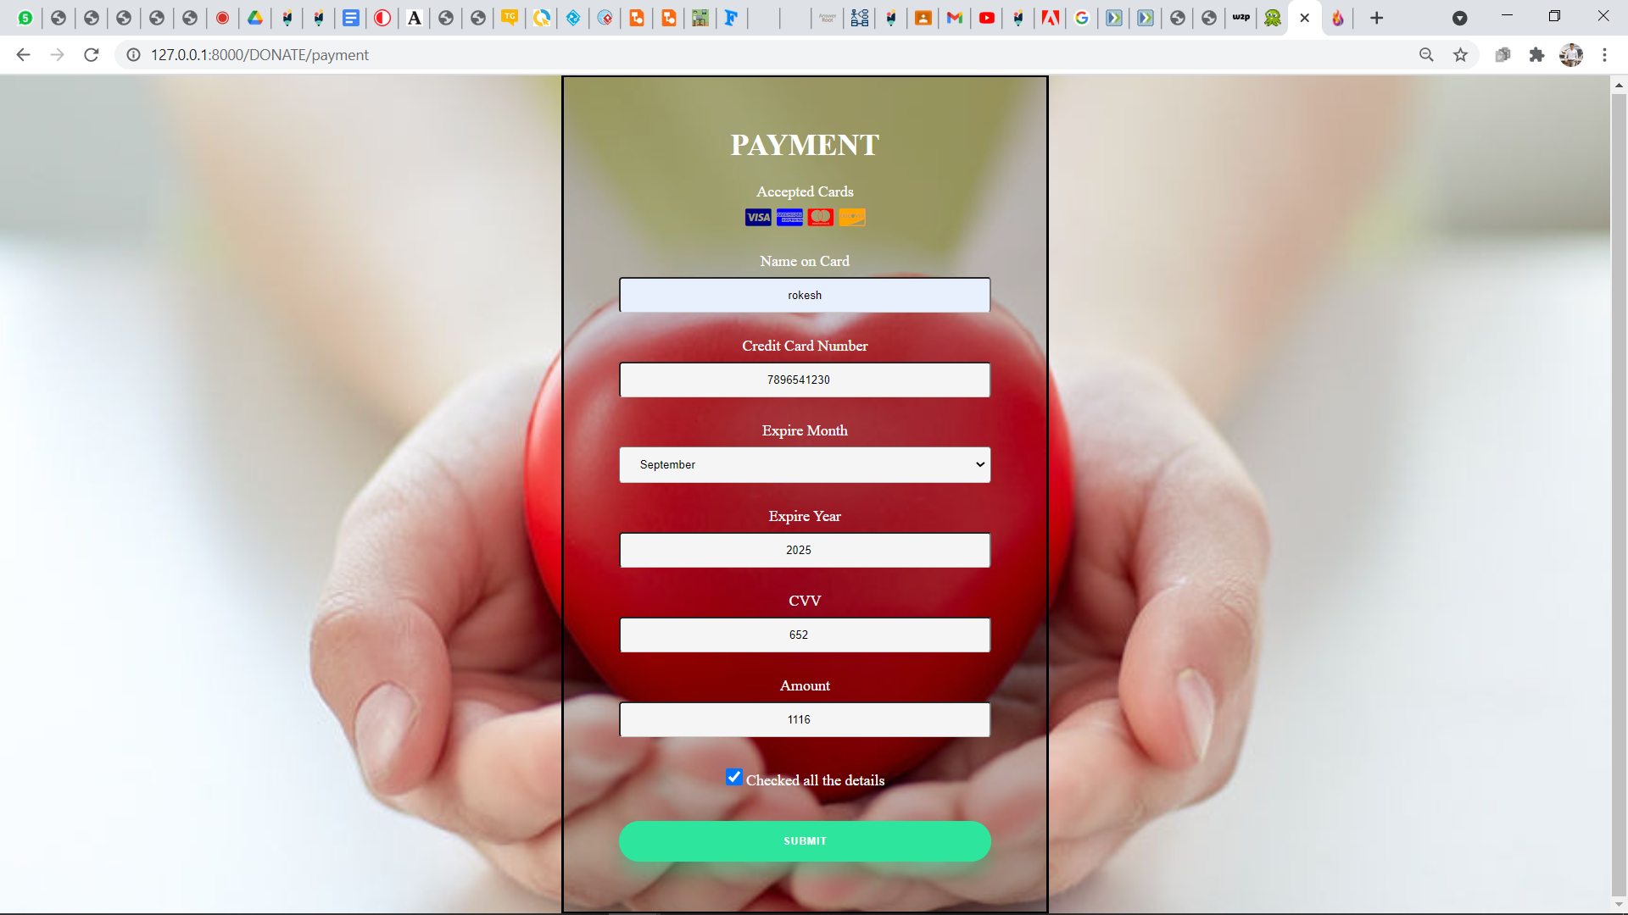

BACKEND PART OF THE PAYMENT FORM:

The Name of the cardholder and amount given by the user is stored in the website database.

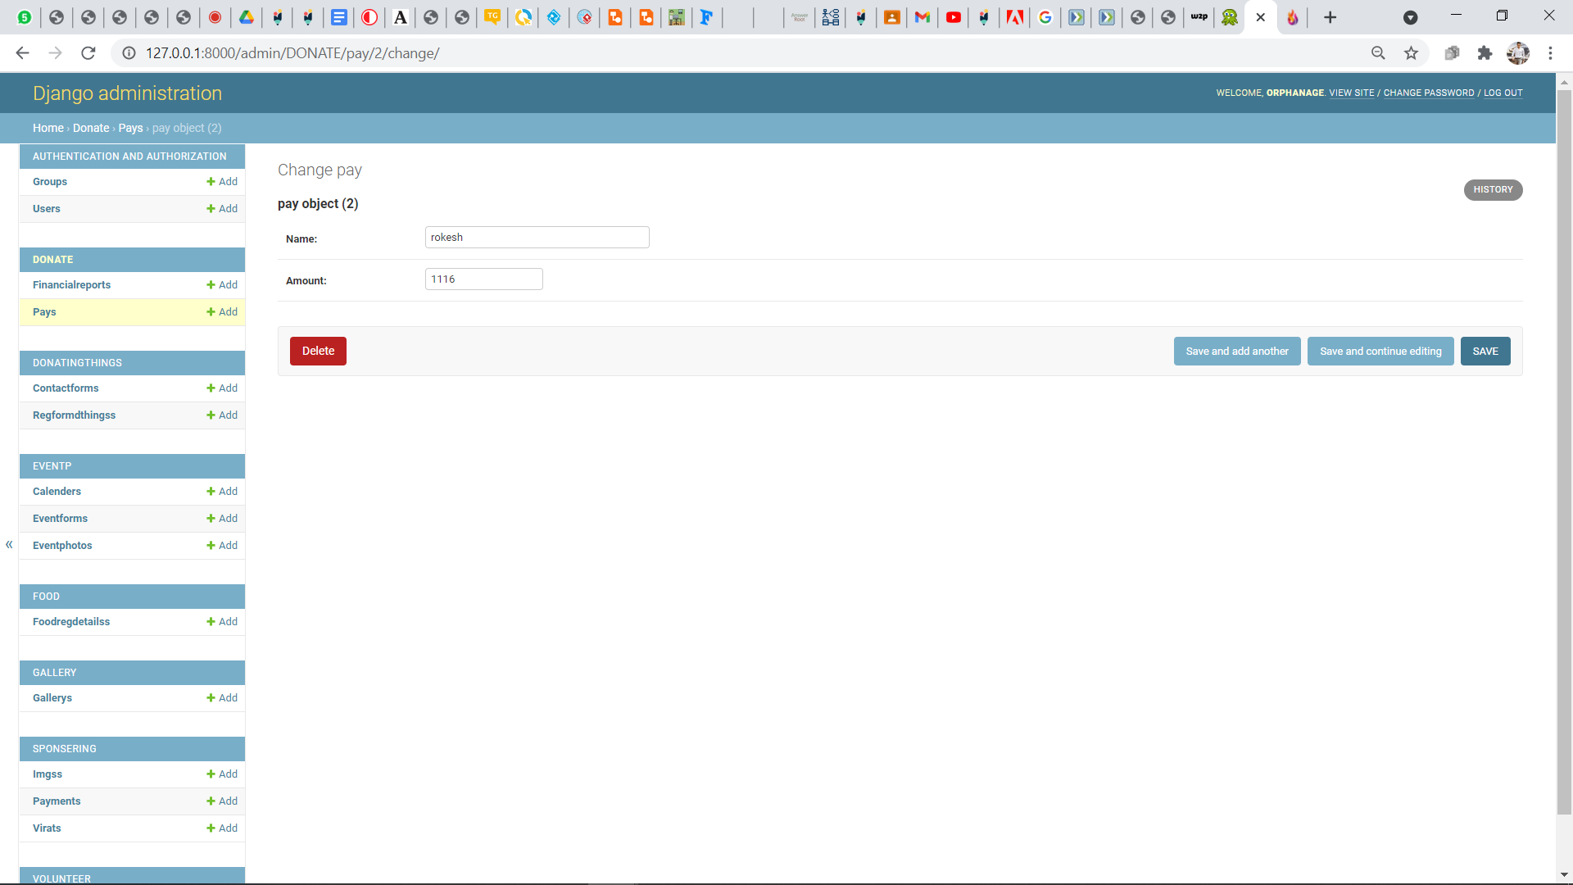

FINANCIAL & AUDIT REPORTS:

The donation page showcase the respective years FINANCIAL reports and also AUDIT reports. And the page shows the user how the donation money used and where it goes.

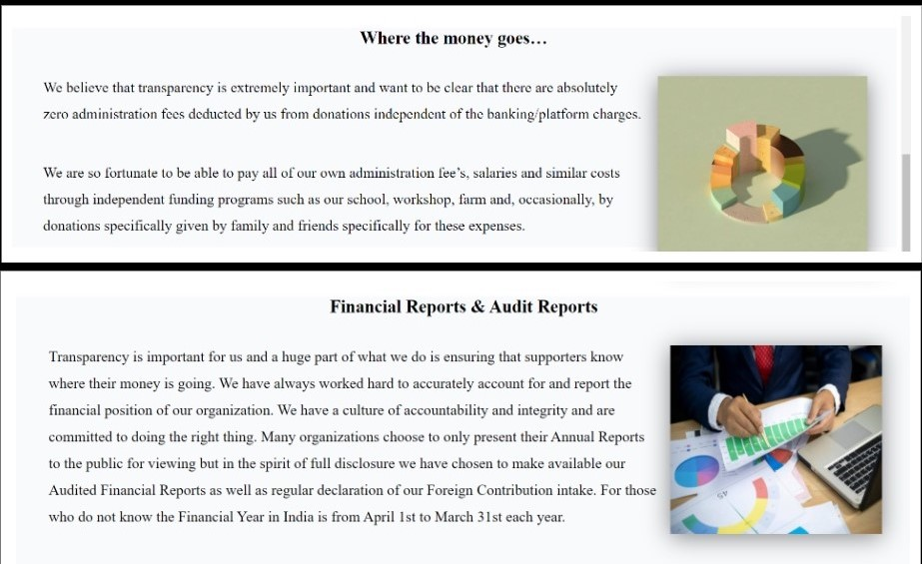

After clicking the buttons FINANCIAL and AUDIT reports it will take the user to FINANCIAL and AUDIT reports files page.

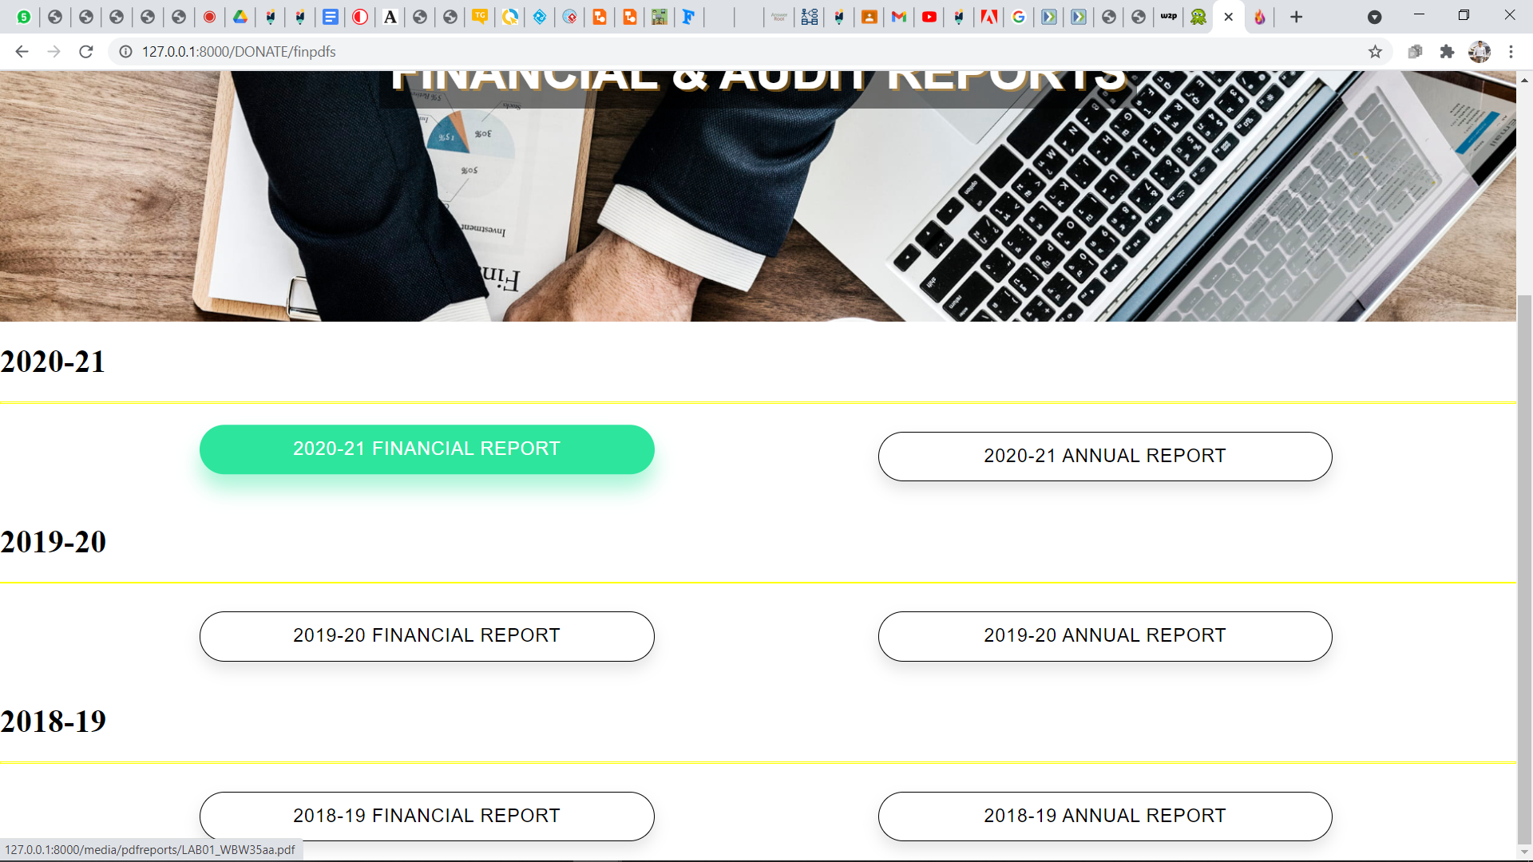

BACKEND OF THE FINANCIAL & AUDIT reports:

The Admin can update the FINANCIAL & AUDIT reports of the respective years from the admin panel of the website.

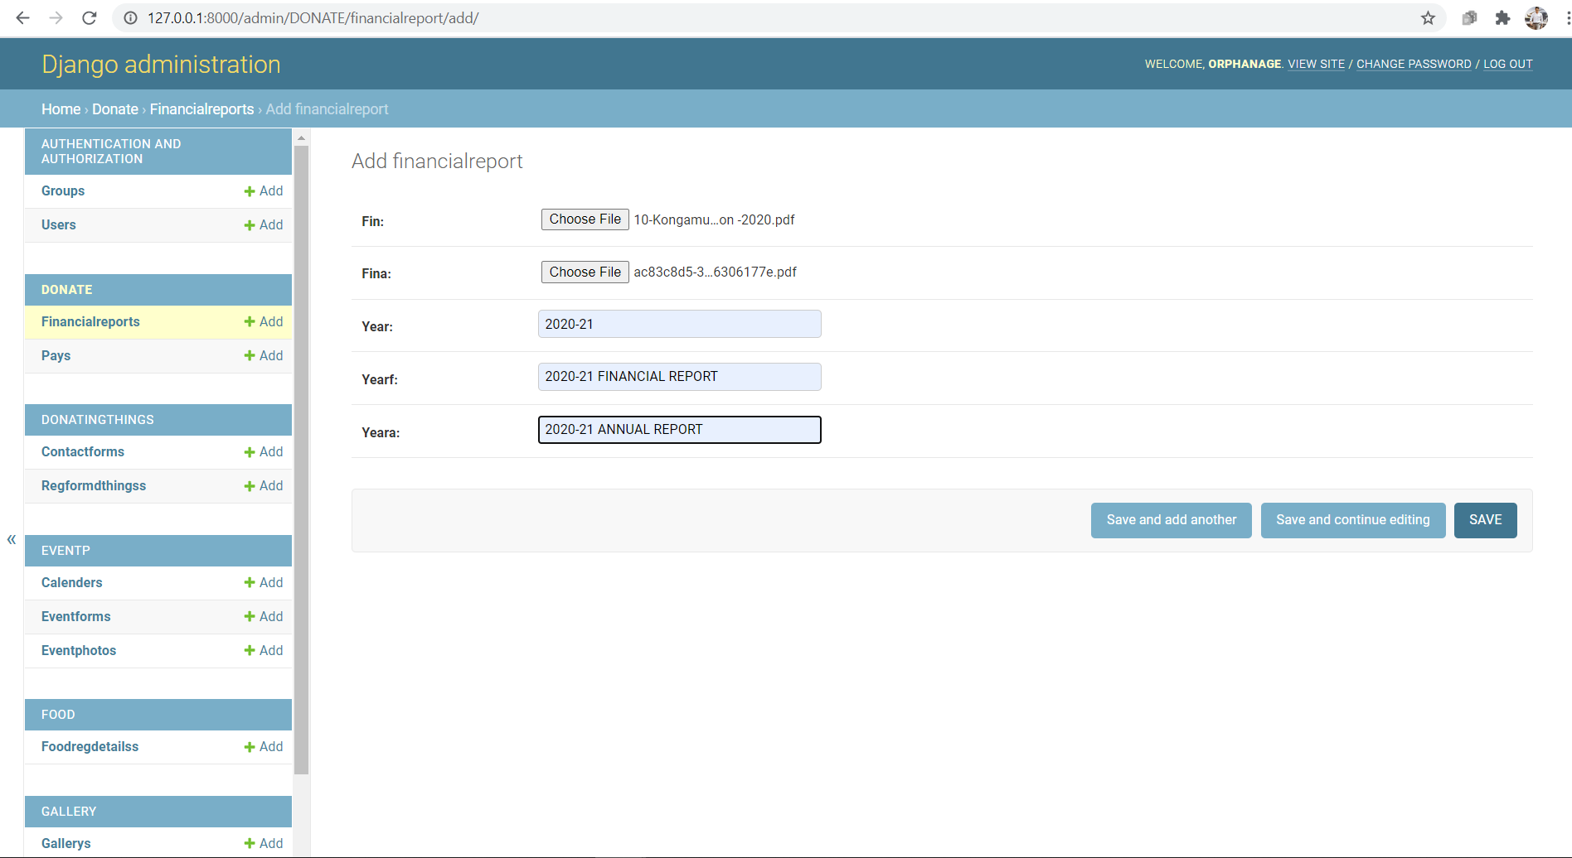

“dont” function is to receive web request from user and redirect to the donate page of the website(web response), "dtreform" function is for form in donating things form page which seeks the payment details of sponsors.

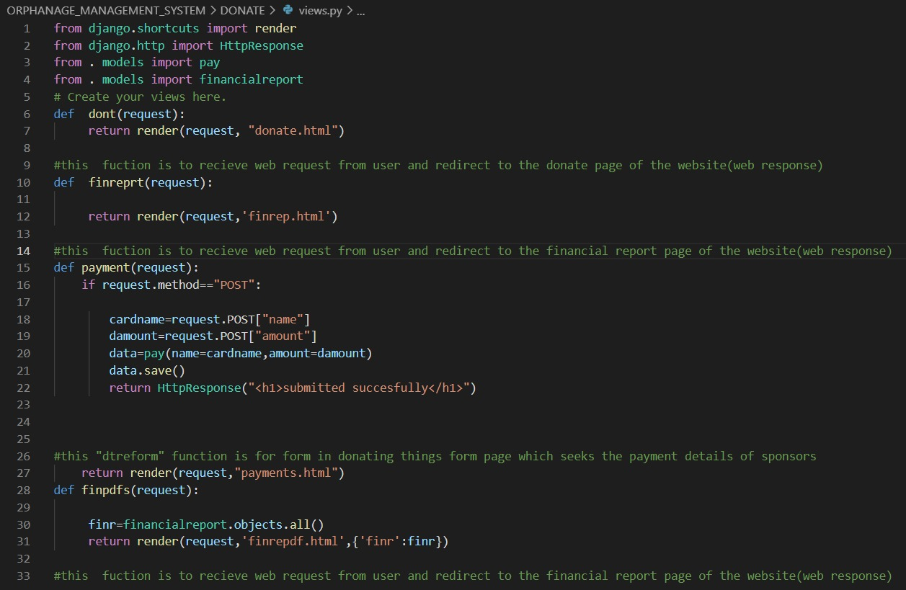

"pay" class in models.py represents tables or collection in our database for the payment of the website

"financialreport" class in models.py represents tables or collection in our database for the pdf files in financial report page of the website #FileField is used for storing valid pdf files into the database. One can any type of image file in FileField.

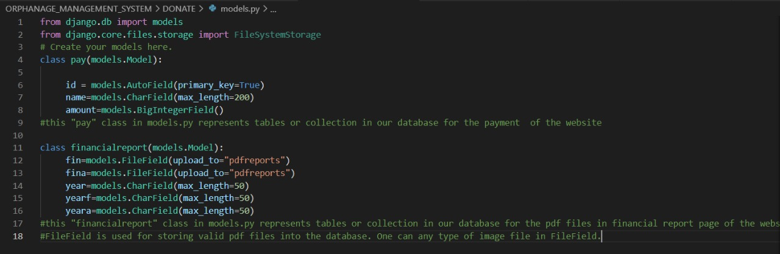

**DATABASE QUERIES**

CREATE TABLE "food_foodregdetails" ("id" serial NOT NULL PRIMARY KEY, "fname" varchar(50) NOT NULL, "lname" varchar(50) NOT NULL, "email" varchar(254) NOT NULL, "phone" bigint NOT NULL, "food1" varchar(1) NULL, "food2" varchar(4) NULL, "fooddate" timestamp with time zone NOT NULL, "foodQuantity" integer NULL, "foodpack" varchar(1) NULL, "locality" varchar(50) NOT NULL, "city" varchar(50) NOT NULL, "district" varchar(50) NOT NULL, "state" varchar(50) NOT NULL, "pin" varchar(10) NOT NULL); => THIS STORES SURPLUS FOOD DETAILS ENTER BY THE USER

CREATE TABLE "DONATE_pay" ("id" serial NOT NULL PRIMARY KEY, "name" varchar(200) NOT NULL, "amount" bigint NOT NULL); =>THIS STORES DONOR NAME & AMOUNT.

CREATE TABLE "DONATE_financialreport" ("id" bigserial NOT NULL PRIMARY KEY, "fin" varchar(100) NOT NULL, "fina" varchar(100) NOT NULL, "year" varchar(50) NOT NULL, "yearf" varchar(50) NOT NULL, "yeara" varchar(50) NOT NULL); => THIS STORES FINANCIAL & AUDIT reports pdf files.

CREATE TABLE "donatingthings_regformdthings" ("id" bigserial NOT NULL PRIMARY KEY, "fname" varchar(50) NOT NULL, "lname" varchar(50) NOT NULL, "email" varchar(254) NOT NULL, "gender" varchar(1) NULL, "age" integer NOT NULL, "pnumber" bigint NOT NULL, "ntoys" varchar(50) NOT NULL, "nbooks" varchar(50) NOT NULL, "nblankets" varchar(50) NOT NULL, "dress" varchar(50) NOT NULL, "cgender" varchar(1) NULL, "others" varchar(50) NOT NULL, "adress" varchar(5000) NOT NULL, "landmark" varchar(50) NOT NULL, => THIS STORES THINGS DONATION FORM DETAILS.

CREATE TABLE "donatingthings_contactform" ("id" bigserial NOT NULL PRIMARY KEY, "name" varchar(50) NOT NULL, "phone" bigint NOT NULL, "email" varchar(254) NOT NULL, "subject" varchar(50) NOT NULL, "message" varchar(100) NOT NULL); => THIS STORES USER QUERIES PROVIDED IN THE CONTACT US PAGE.

CREATE TABLE "Eventp_calender" ("id" bigserial NOT NULL PRIMARY KEY, "date" varchar(3) NOT NULL, "month" varchar(15) NOT NULL, "specialday" varchar(50) NOT NULL, "description" varchar(250) NOT NULL, "time" varchar(10) NOT NULL); => THIS STORES EVENT CALENDAR DATA

CREATE TABLE "Eventp_eventform" ("id" bigserial NOT NULL PRIMARY KEY, "first_name" varchar(50) NOT NULL, "last_name" varchar(50) NOT NULL, "email" varchar(50) NOT NULL, "Gender" varchar(1) NULL, "Age" integer NOT NULL, "Phone" bigint NOT NULL, "Category" varchar(1) NULL, "People" integer NOT NULL, "Event_Date" timestamp with time zone NOT NULL, "Event_Celebrations" varchar(1) NULL); => THIS STORES EVENT DETAILS ENTERED BY USER.

CREATE TABLE "Eventp_eventphoto" ("id" bigserial NOT NULL PRIMARY KEY, "img" varchar(100) NOT NULL, "info" varchar(50) NOT NULL); => THIS STORES PHOTOS IN EVENT GALLERY PAGE .

CREATE TABLE "gallery_gallery" ("id" bigserial NOT NULL PRIMARY KEY, "img" varchar(100) NOT NULL, "info" varchar(50) NOT NULL); => THIS STORES PHOTOS IN MAIN GALLERY PAGE.

CREATE TABLE "sponsering_imgs" ("id" serial NOT NULL PRIMARY KEY, "img" varchar(100) NOT NULL, "name" varchar(50) NOT NULL, "age" varchar(50) NOT NULL); => THIS STORES THE PHOTOS,DETAILS OF ORPHANS WAITING FOR ORPHANS.

CREATE TABLE "sponsering_payment" ("id" serial NOT NULL PRIMARY KEY, "name" varchar(200) NOT NULL, "card" bigint NOT NULL); => THIS STORES THE DETAILS ENTERED BY SPONSOR.

CREATE TABLE "sponsering_virat" ("id" serial NOT NULL PRIMARY KEY, "fname" varchar(50) NOT NULL, "lname" varchar(50) NOT NULL, "gender" varchar(7) NULL, "email" varchar(50) NOT NULL, "phone" bigint NOT NULL, "Role" varchar(200) NOT NULL, "amount" integer NOT NULL, "address" varchar(500) NOT NULL, "message" varchar(200) NOT NULL); => THIS STORES THE DETAILS ENTERED BY THE SPONSOR.

CREATE TABLE "volunteer_volunteer" ("id" serial NOT NULL PRIMARY KEY, "fname" varchar(50) NOT NULL, "lname" varchar(50) NOT NULL, "gender" varchar(7) NOT NULL, "availability" varchar(2) NOT NULL, "email" varchar(200) NOT NULL, "phone" bigint NOT NULL, "role" varchar(400) NOT NULL, "address" varchar(50) NOT NULL, "message" varchar(50) NOT NULL); => THIS STORES THE DETAILS ENTERED BY THE USER FOR VOLUNTEER REGISTRATION.